**Data Movement and Transformation**

* **Sharath Chandra**

**PROJECT OVERVIEW:**

In this project, we aim to implement a robust real-time data processing solution leveraging the capabilities of Azure Data Factory (ADF) and Azure Databricks. The primary objective is to ingest streaming data seamlessly through ADF and conduct near-real-time processing and analysis using Spark streaming in Azure Databricks.

**ABOUT THE PROJECT:**

This project is all about handling data in real-time, meaning we want to work with information as soon as it comes in, without any delays.

We're using two key tools from Microsoft's Azure cloud platform:

i)Azure Data Factory (ADF)

ii)Azure Databricks.

**i)Azure Data Factory(ADF)**:Azure Data Factory helps us bring in data from different sources, like devices or sensors, in a smooth and organised way.

**ii)Azure Databricks:**Once we have the data, we pass it over to Azure Databricks. Here, using a powerful tool called Spark Streaming, we can process and understand the data almost immediately. It's like getting answers in real-time rather than waiting. The processed data can then be stored or shown in a way that makes sense, maybe using tools like Azure Databricks for creating easy-to-read charts or graphs. The whole idea is to quickly make sense of the data as it flows in, helping businesses make faster and smarter decisions.

**ARCHITECTURE DIAGRAM:**

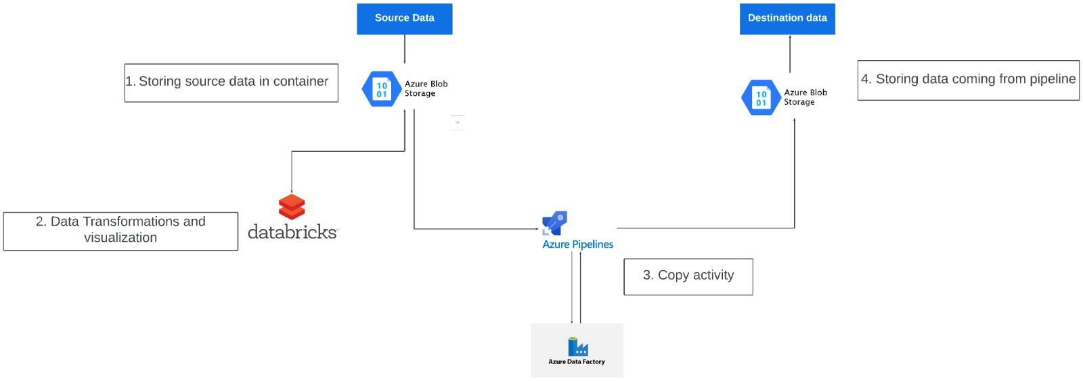

**HOW IT WORKS:**

**i)Data Ingestion with Data Factory:**

Create data ingestion pipelines in Azure Data Factory to ingest data from various sources into Azure Blob Storage Implement real-time data ingestion where applicable.

**ii)Transform data with Azure Databricks:**

Develop real-time analytics solutions using Azure Databricks to process data streams and derive insights. Implement data transformations, aggregations, and machine learning algorithms for analytics.

**AZURE RESOURCES USED FOR THIS PROJECT:**

**Azure Data Factory:** Orchestrates data pipelines for seamless movement and transformation across various sources, facilitating efficient data integration and management.

**Azure Databricks:** Provides an optimized Apache Spark environment for collaborative data analysis and machine learning tasks in the Azure cloud, streamlining big data processing workflows.

**Azure Storage Account (Blob Storage**): Offers scalable and reliable object storage for unstructured data, such as documents and images, with features like high availability and multiple storage tiers for cost optimization.

**Apache Spark (via Azure Databricks):** Empowers data processing and analytics tasks within Azure Databricks through its distributed computing capabilities, supporting multiple programming languages and enabling high-performance analytics at scale.

**PROJECT REQUIREMENTS:**

**Functional Requirements:**

**Azure Subscription Access:** The system must ensure access to an Azure subscription with the necessary permissions to create and manage resources.

**Data Source Configuration:** Identify and configure streaming data sources to be ingested using Azure Data Factory. This includes setting up connections, defining ingestion schedules, and ensuring data integrity during transfer.

**Databricks Workspace Setup:** Create a Databricks workspace and configure Spark clusters to enable real-time data processing. This involves defining cluster configurations, managing dependencies, and ensuring scalability and reliability for processing tasks.

**Storage Configuration:** Configure the Azure Storage Account to store both the ingested and processed data. This includes setting up appropriate containers, defining access controls, and implementing data retention policies.

**Non-Functional Requirements:**

**Security:** Ensure data security throughout the system by implementing appropriate access controls, encryption mechanisms, and compliance measures.

**Scalability:** Design the system to handle varying loads of streaming data efficiently, with the ability to scale resources up or down as needed to meet demand.

**Reliability:** Ensure high availability and fault tolerance of the system components to minimize downtime and data loss, leveraging features like redundancy and automated failover.

**Performance:** Optimize system performance for real-time data processing, including minimizing latency, maximizing throughput, and optimizing resource utilization.

**Cost Efficiency:** Optimize resource utilization and minimize unnecessary costs by implementing cost-effective storage solutions, efficient processing algorithms, and proactive cost monitoring mechanisms.

**OUTPUT/RESULT:**

**Azure Databricks and Spark Stream Visualization:**

**Step 1:** Set up an Azure Databricks workspace in the Azure portal.

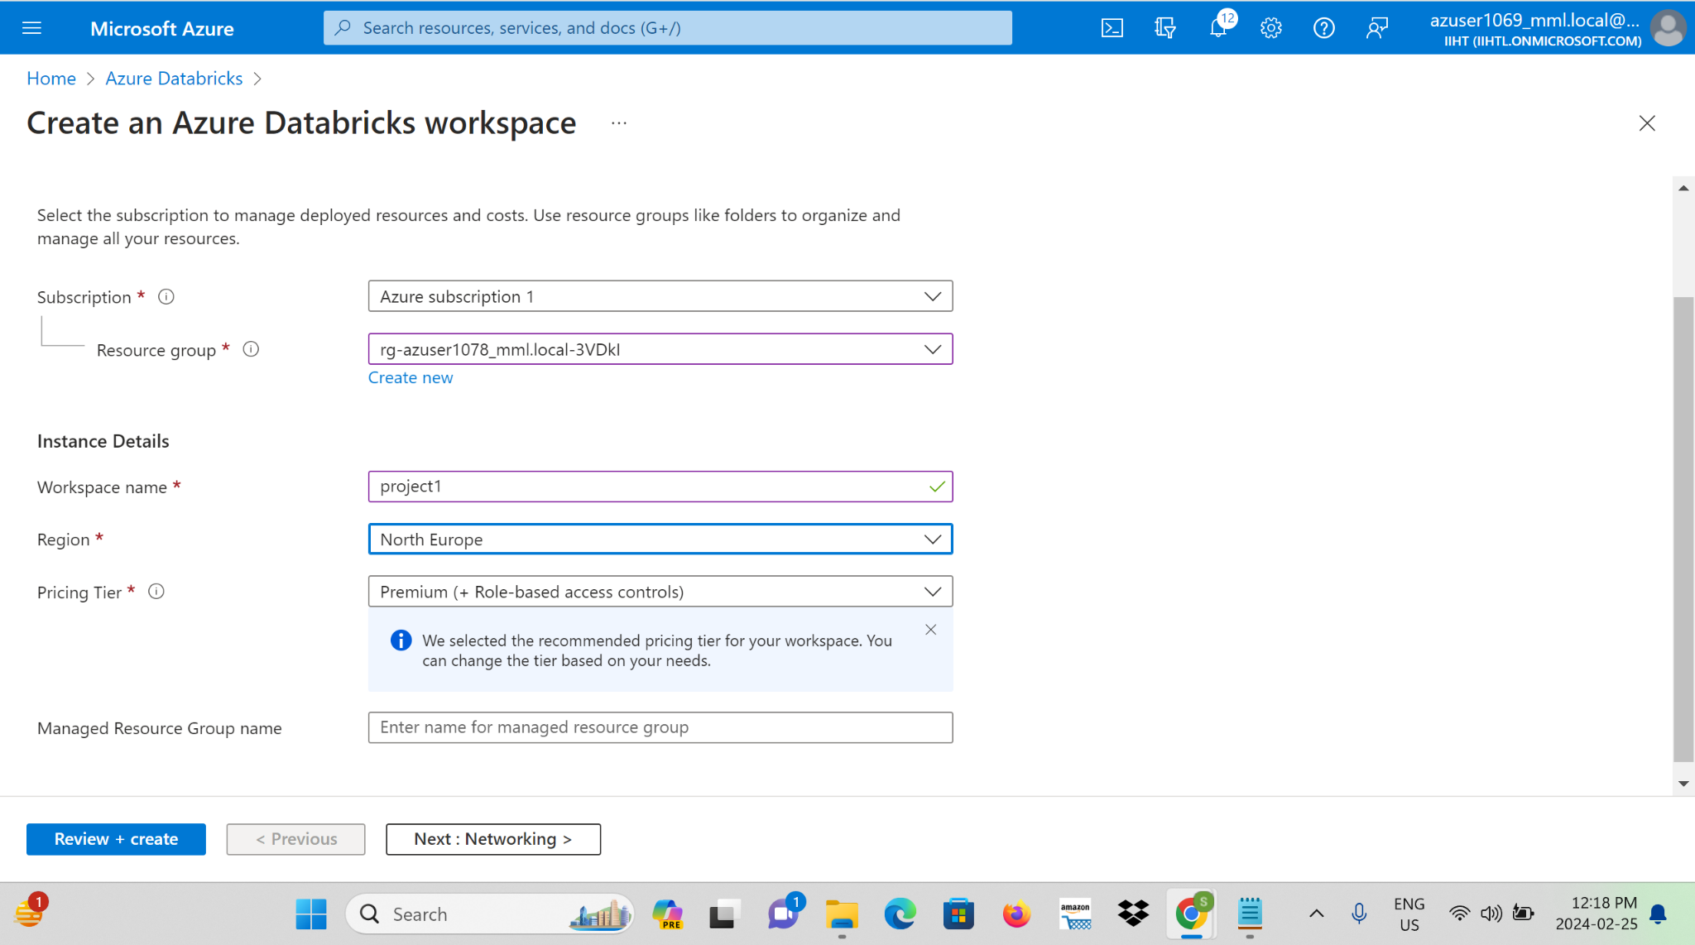

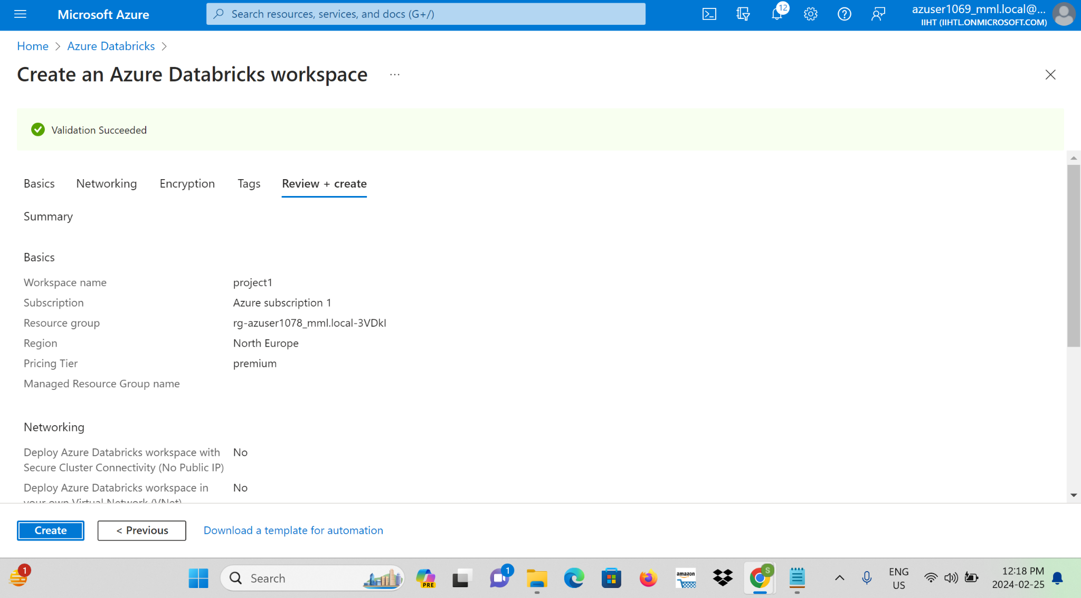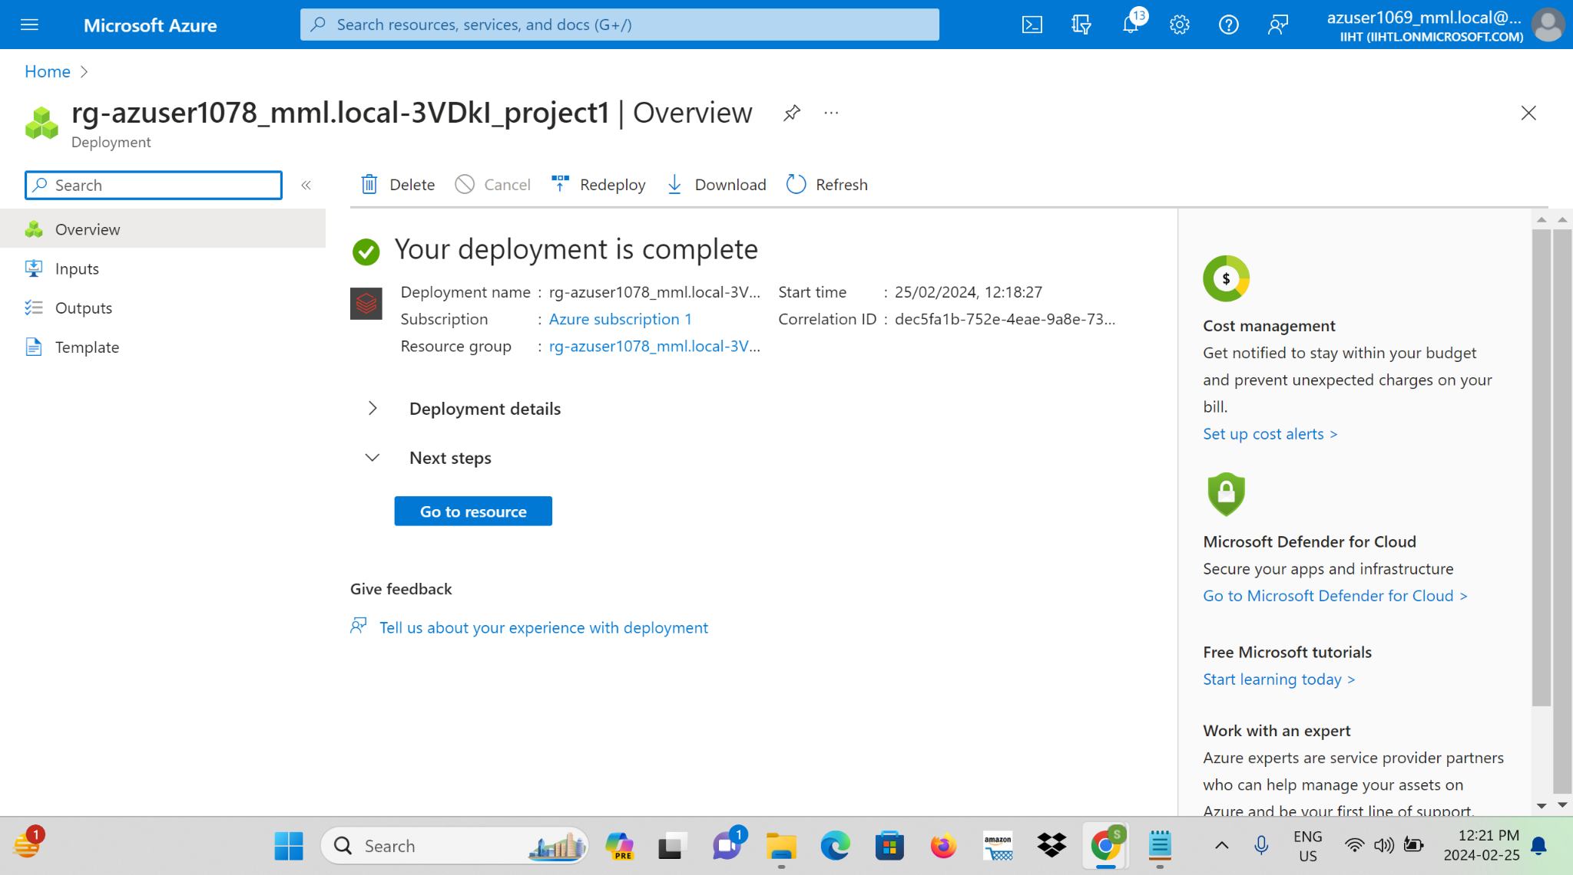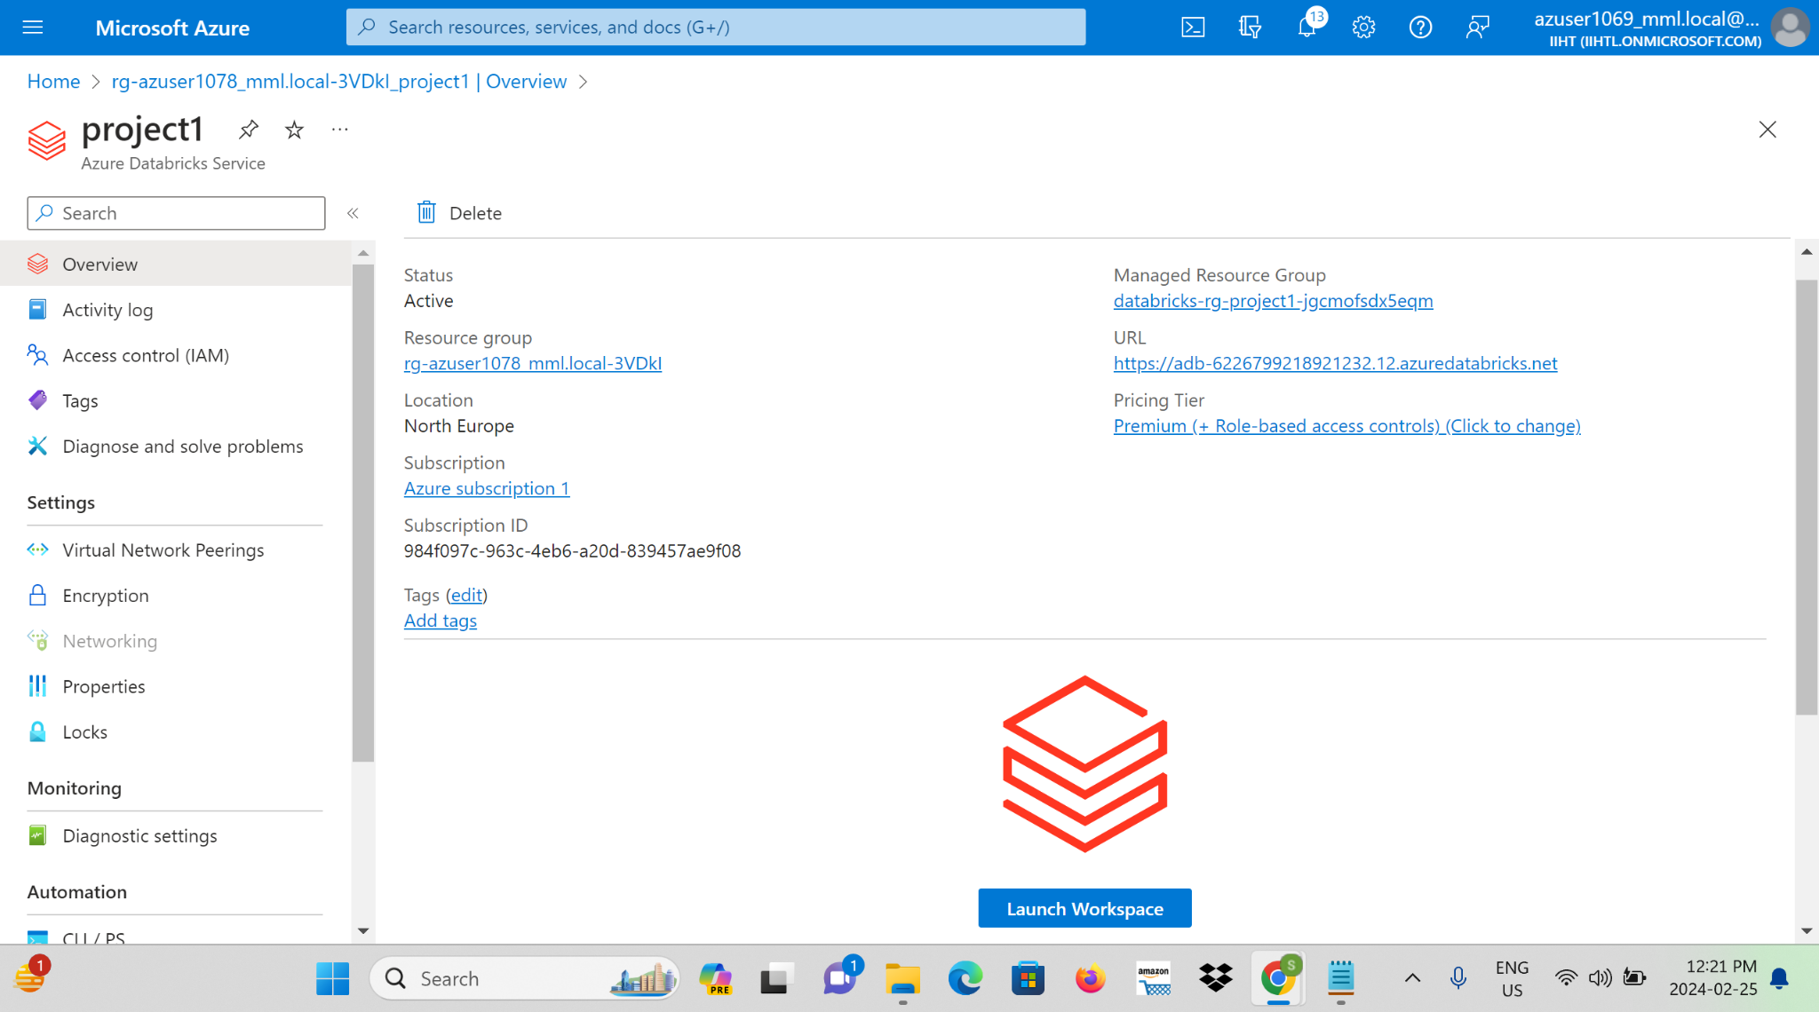

**Step 2:** Create a new Databricks cluster with the desired configuration.

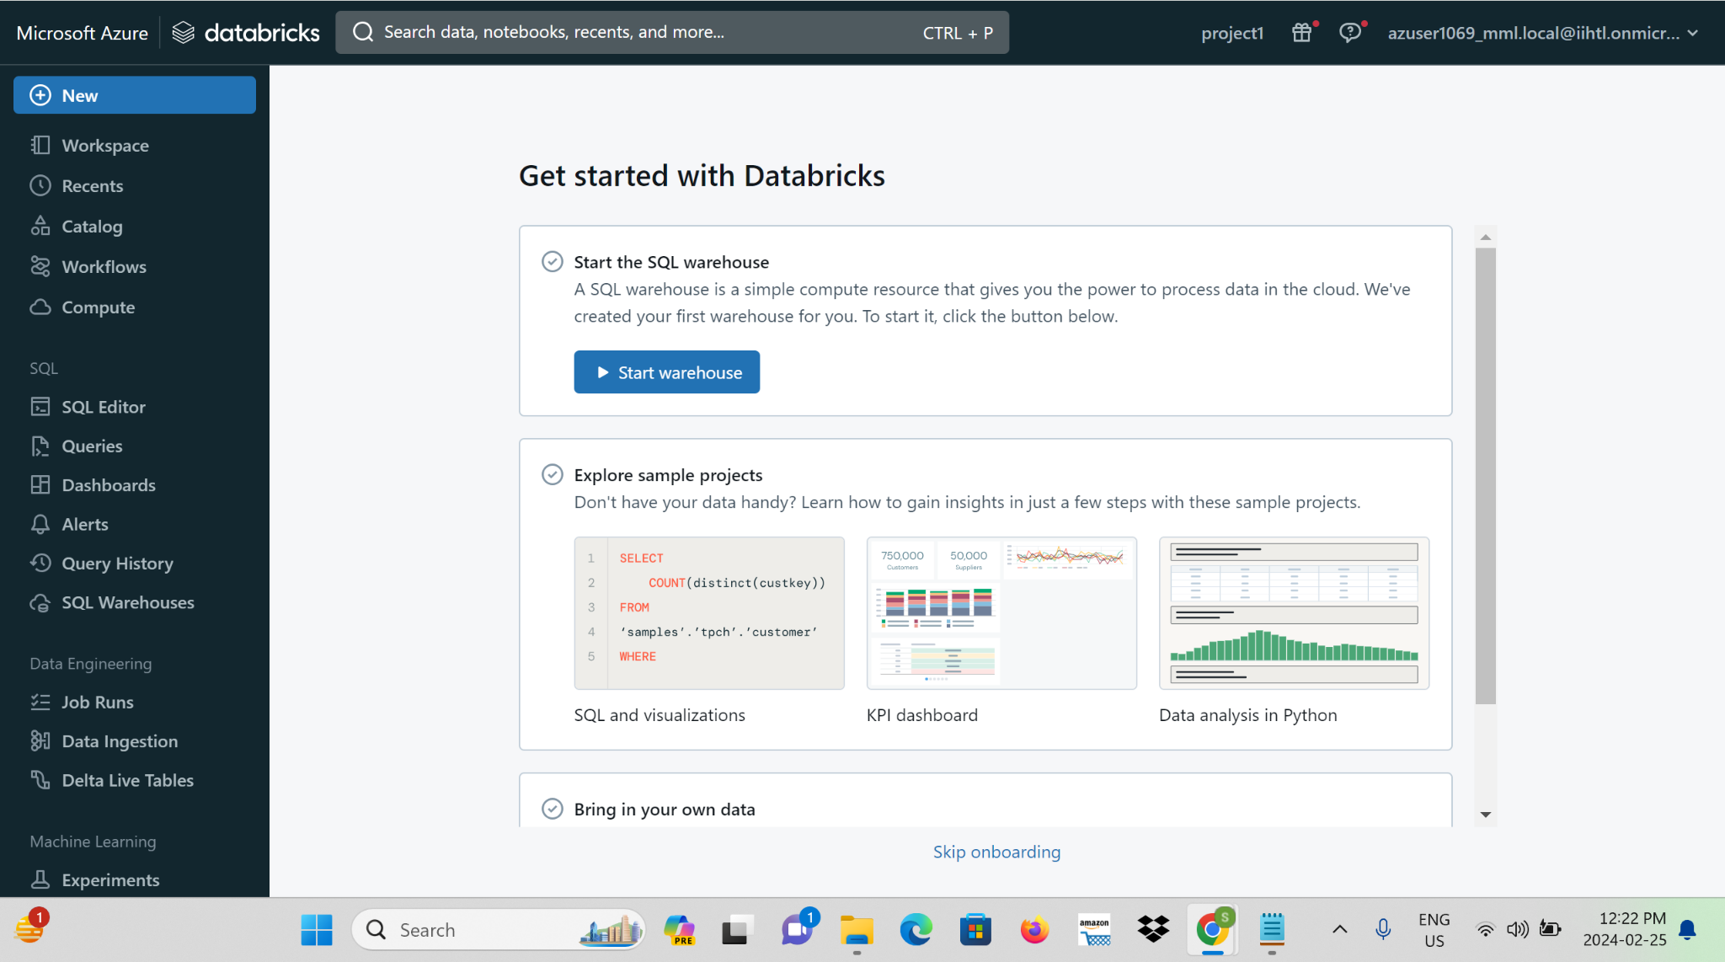

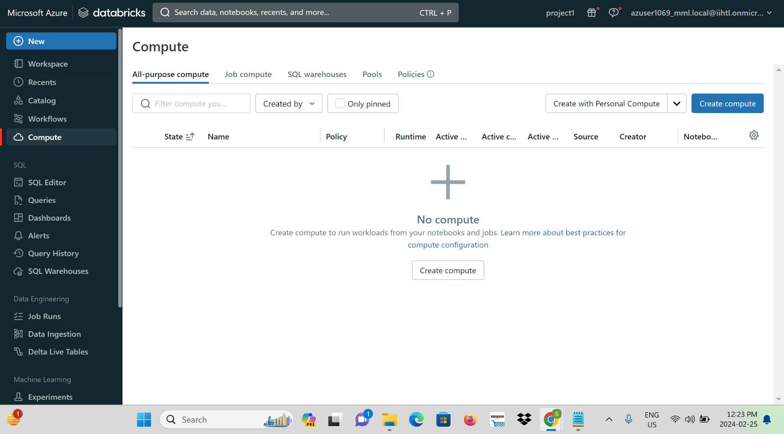

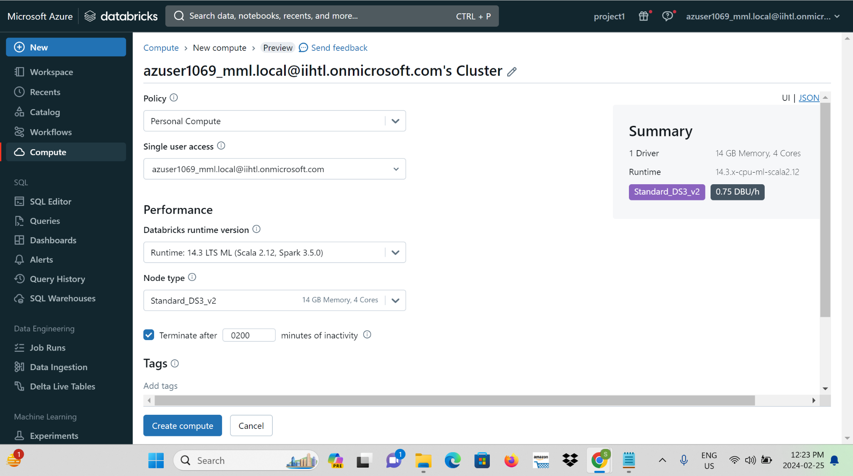

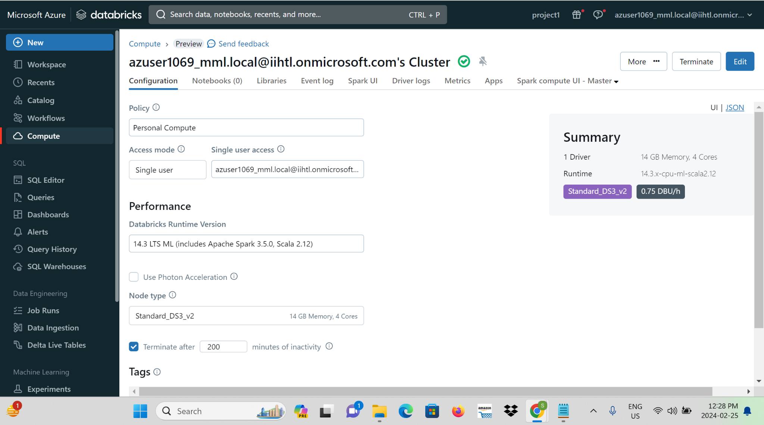

**Step 3:** Open the Databricks workspace and create a new notebook.

**Step 4:** Write and execute Spark streaming code in the notebook to process streaming data.

**i)Importing the data from storage account:**

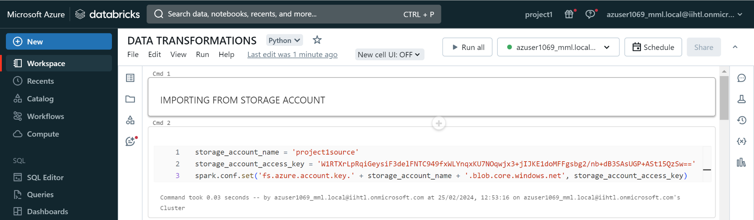

**ii)Giving path:**

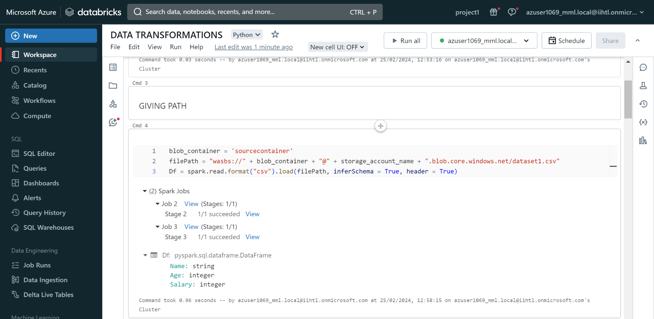

**iii)Importing Pyspark:**

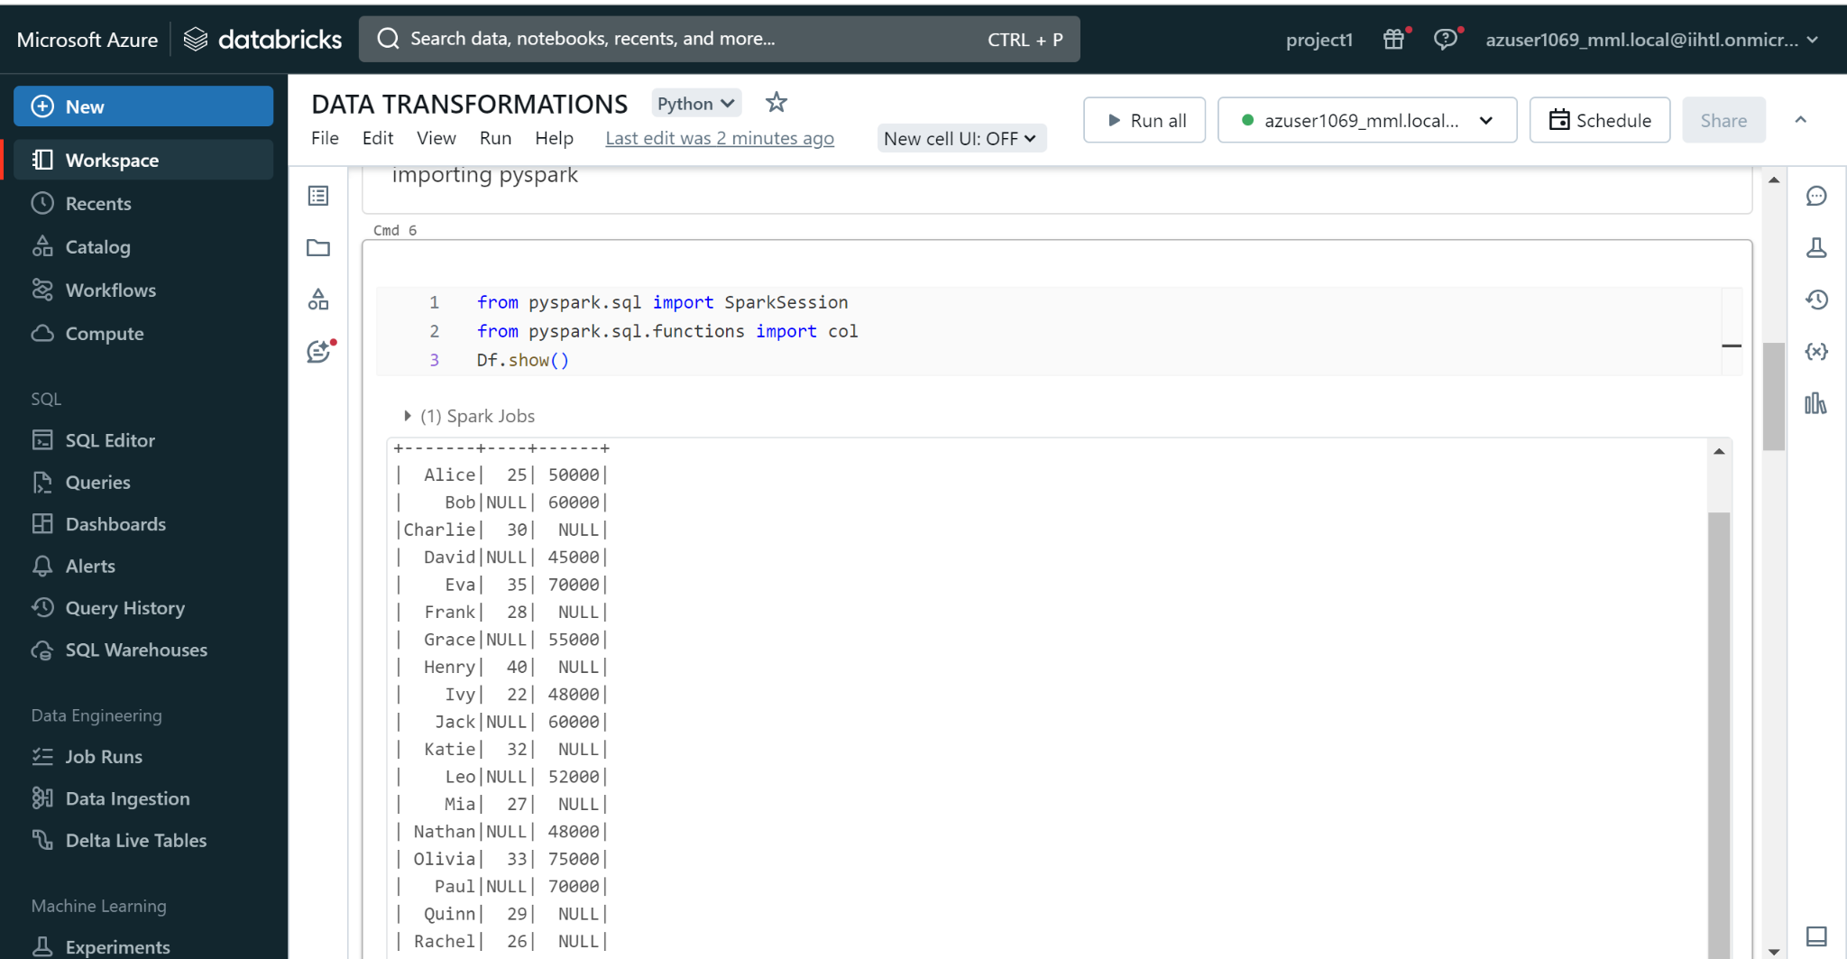

**iv)Describing the Dataframe:**

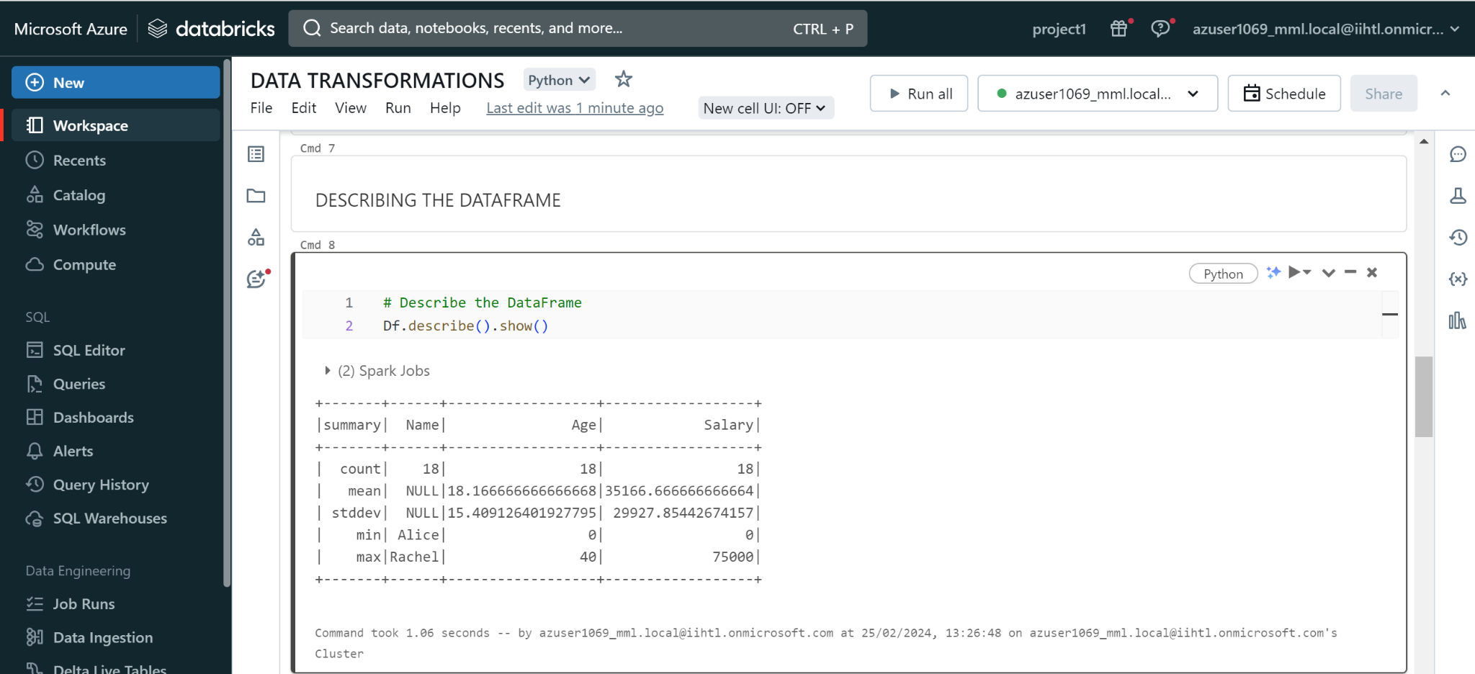

**v)Handling Null Values:**

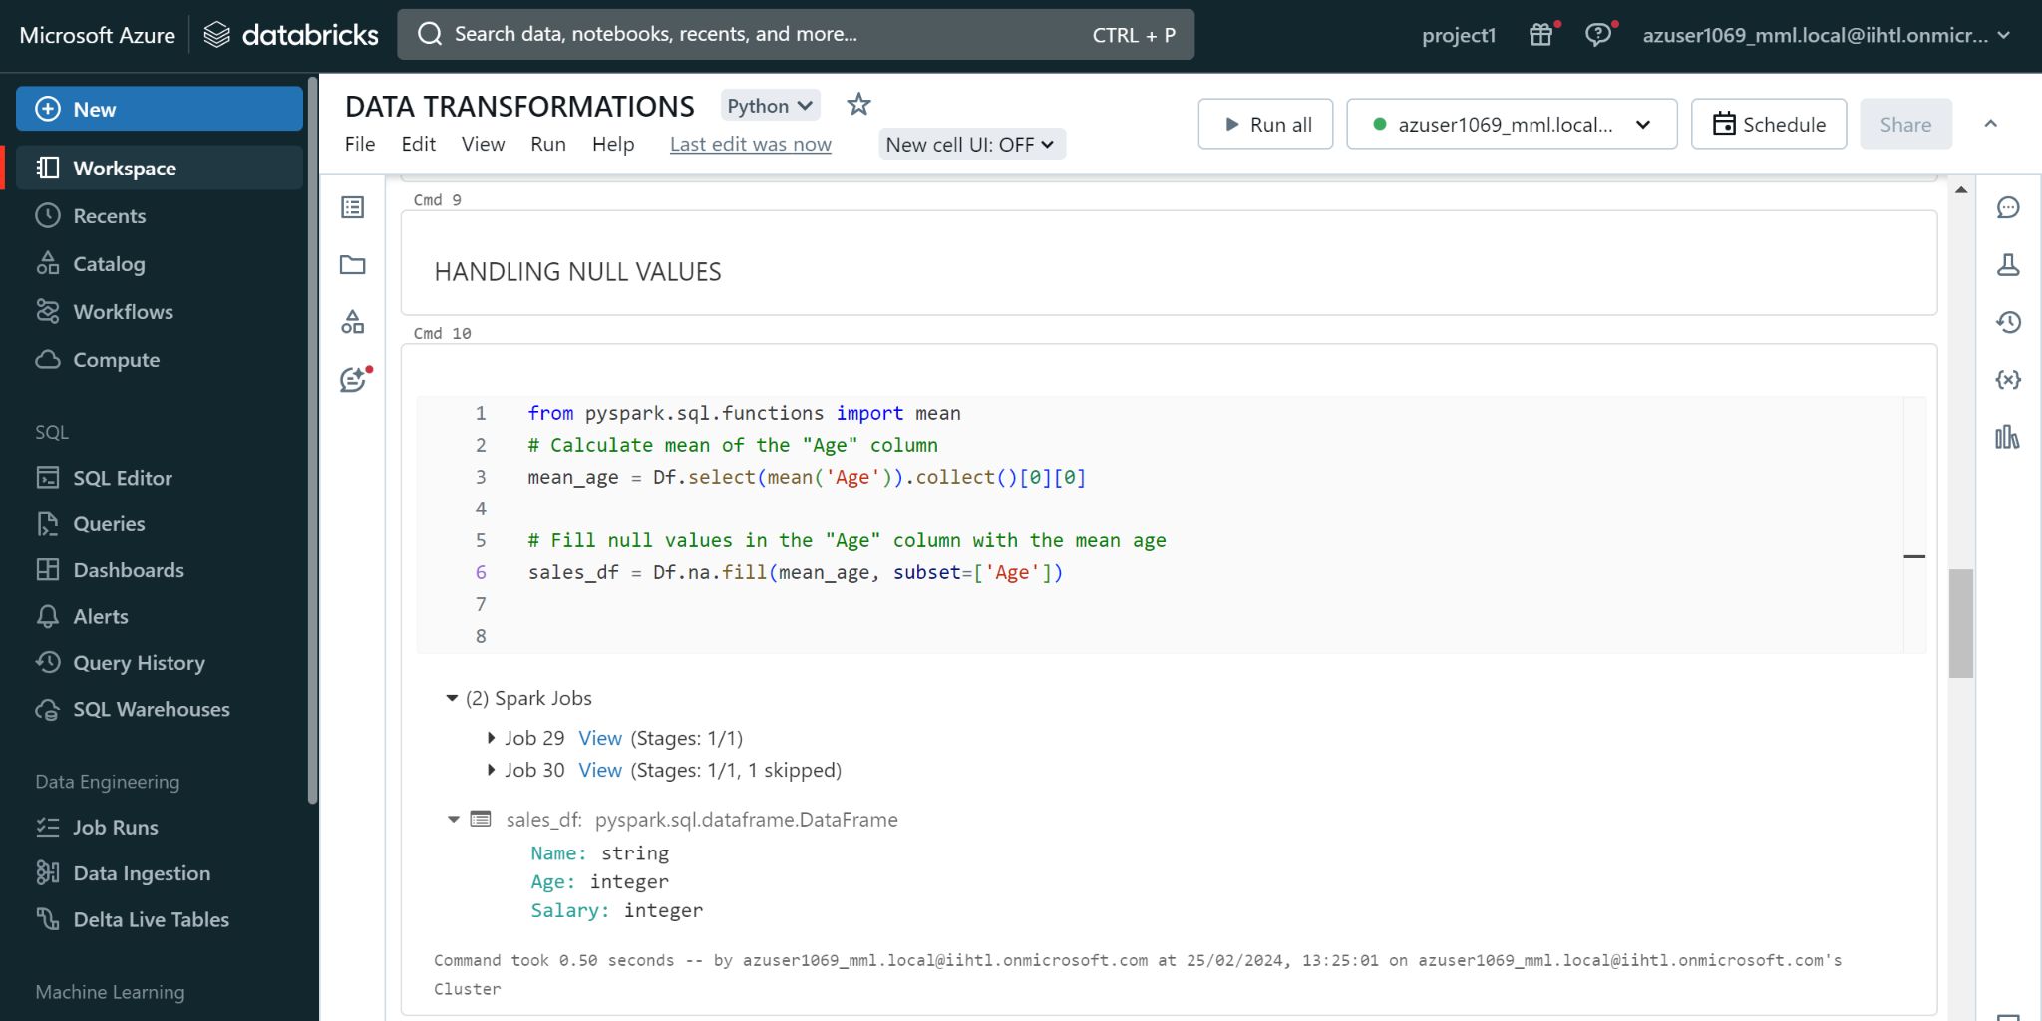

**vi)Performing Aggregate Functions:**

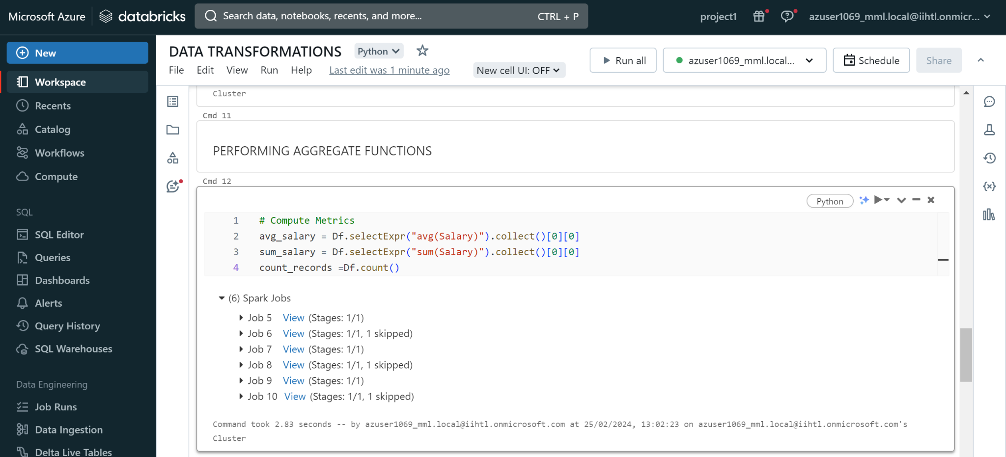

**vii)Displaying Average, Sum, Count Values:**

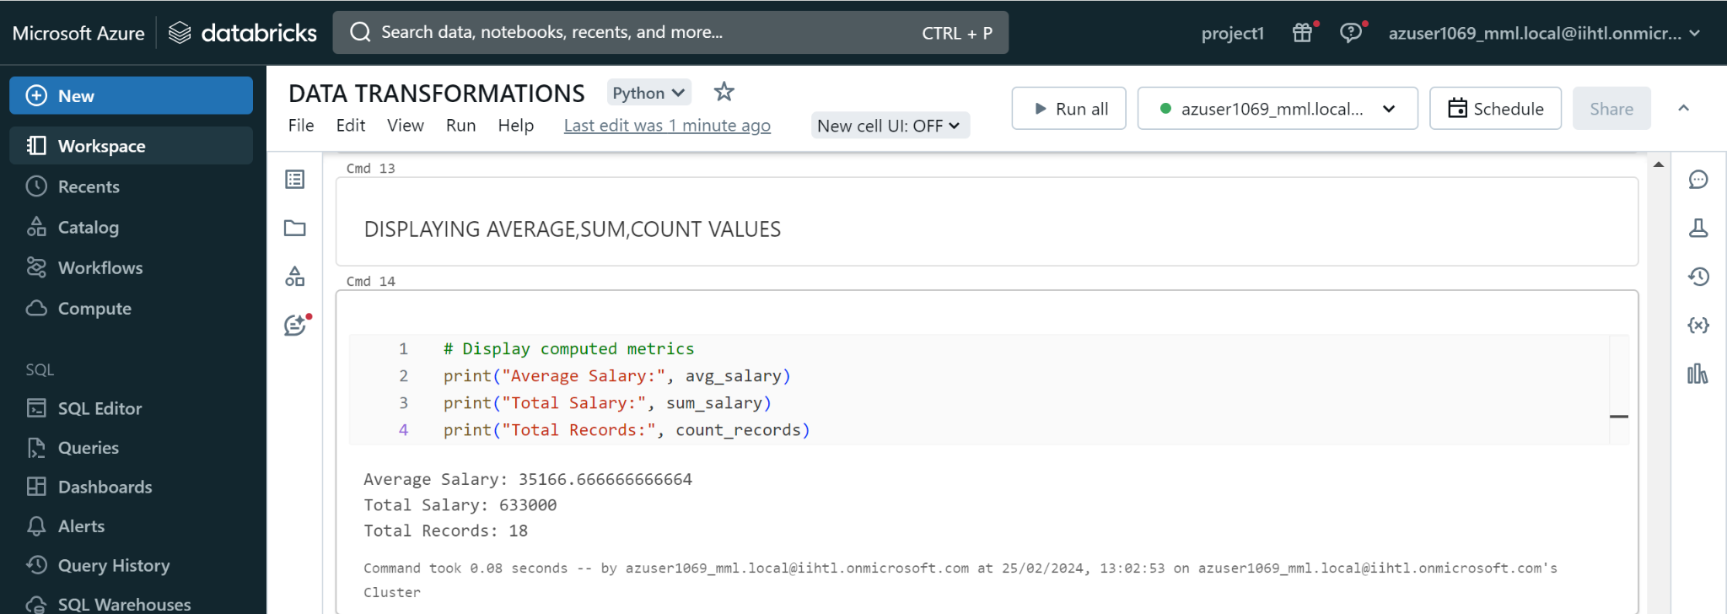

**Step 5:** Visualize and Data profile the streaming data using Databricks visualization spark.readStream

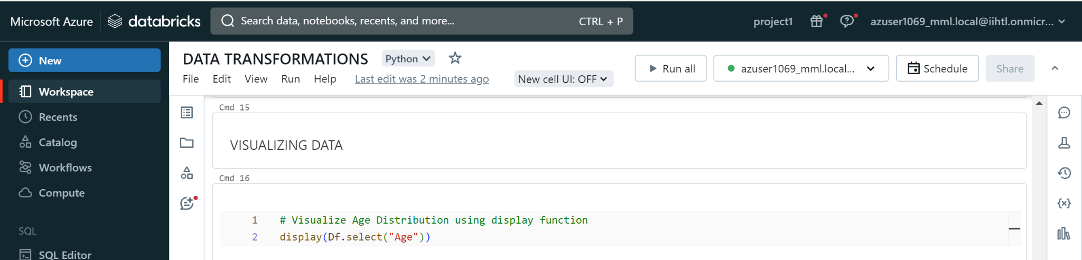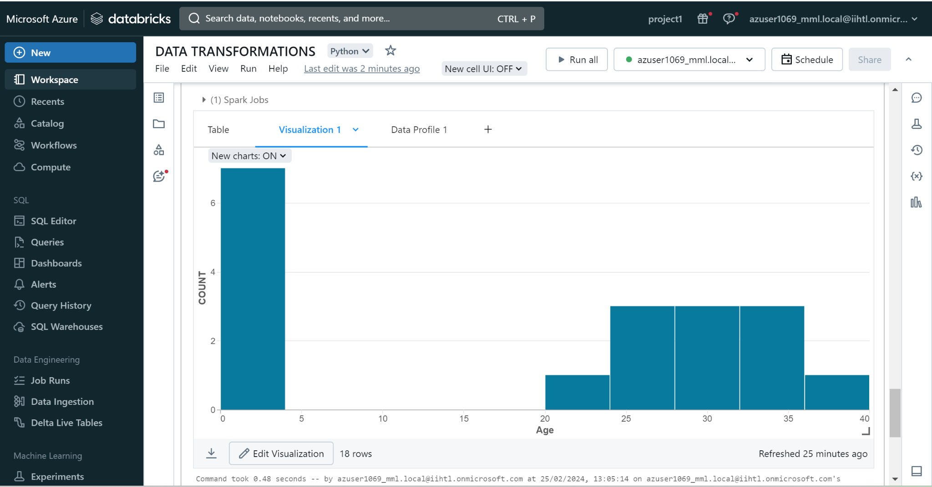

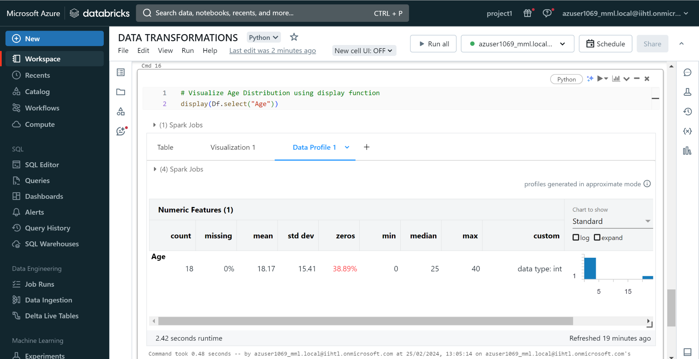

**Data ingestion with Data Factory:**Firstly to ingest the data we need to create a resource group and storage accounts.

**Step 1:**Navigate to the Azure portal and search for resource group and create a resource group.

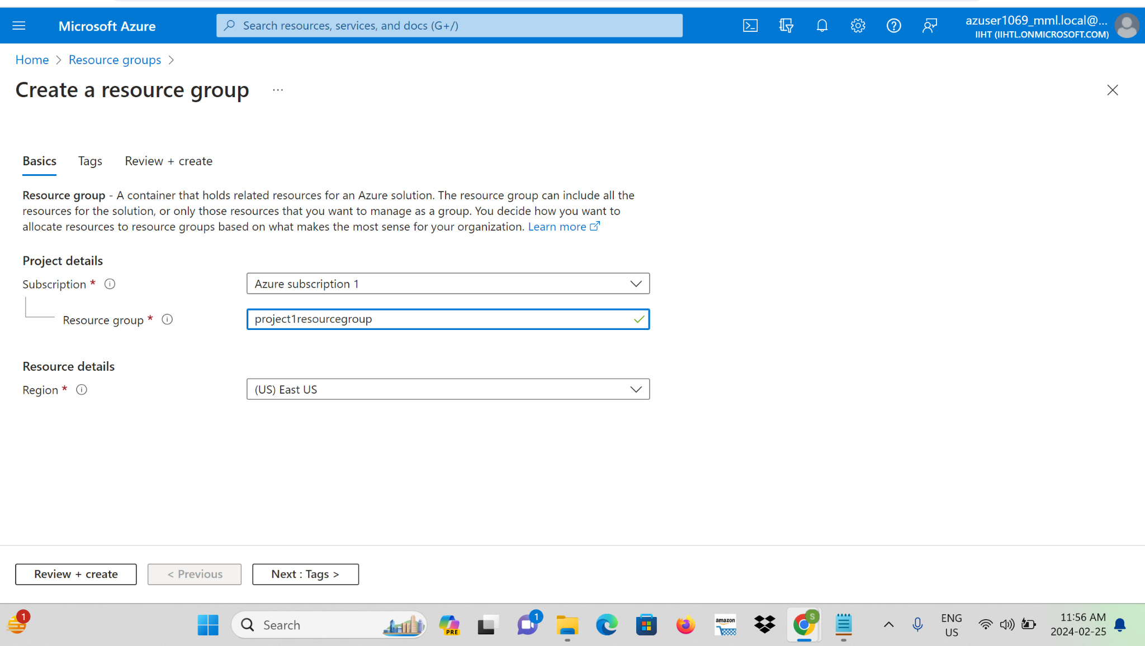

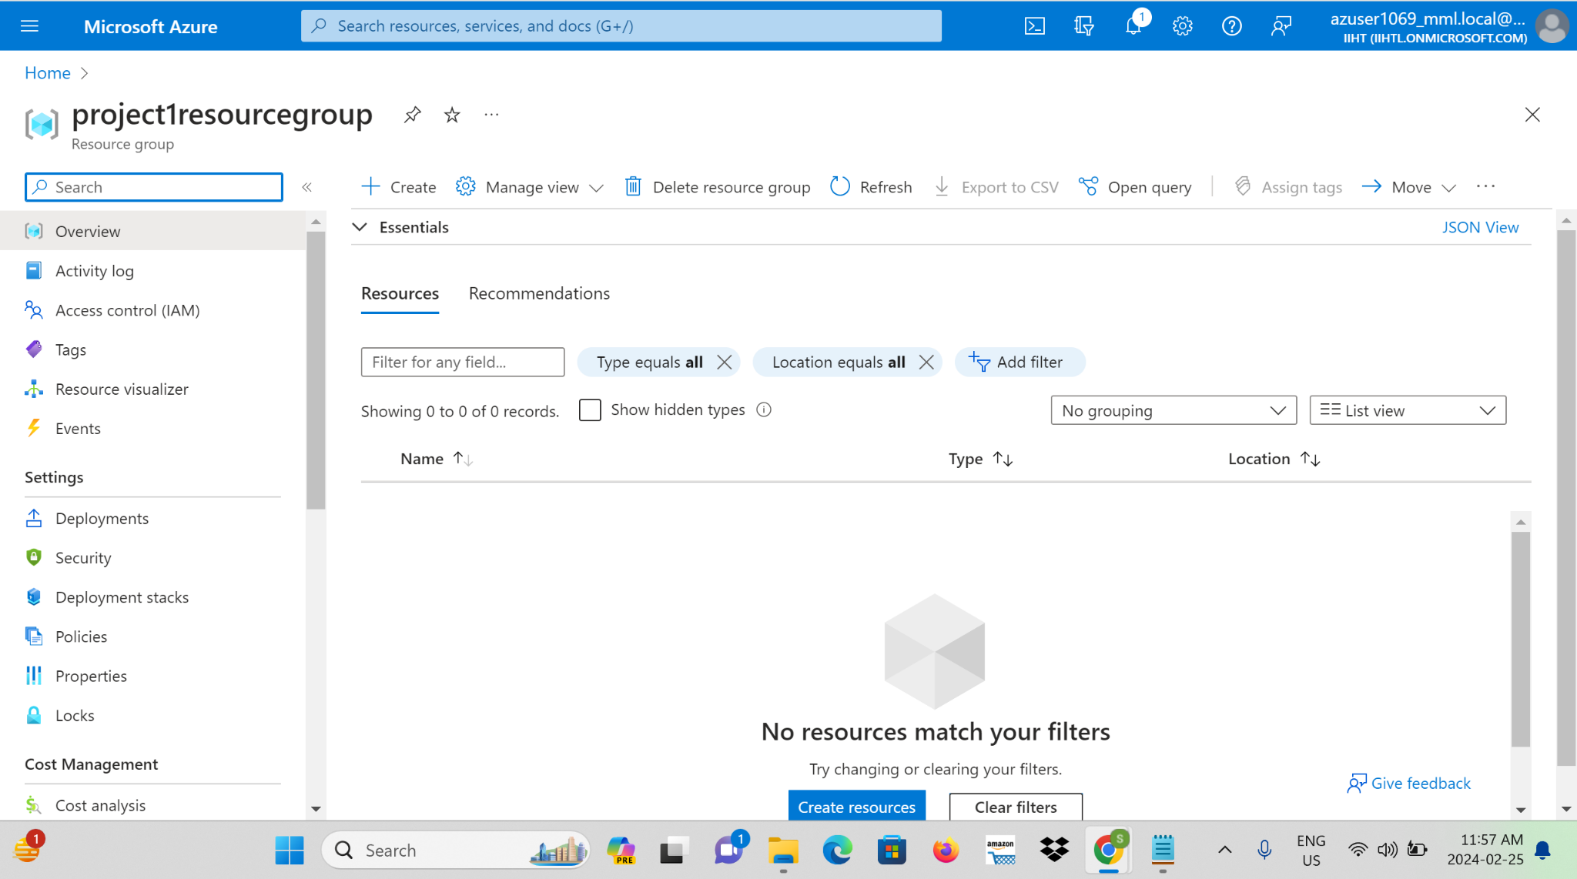

**Step 2**: Again search for the storage account and create a source storage account.

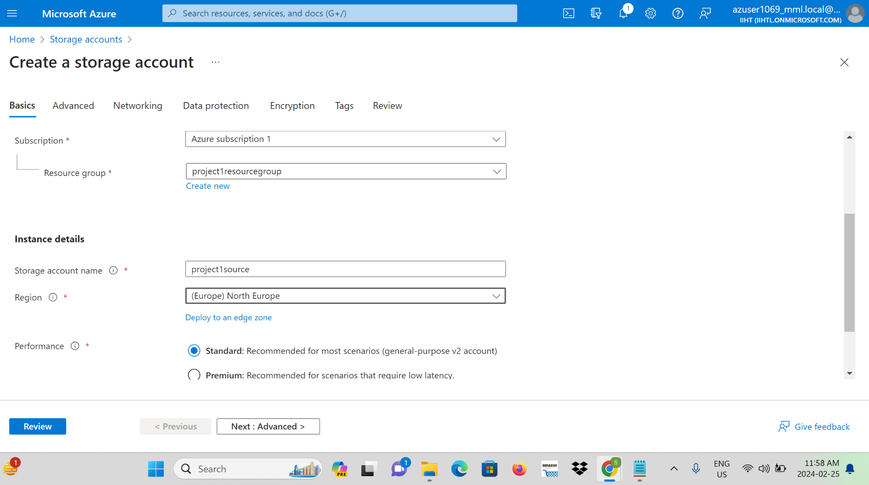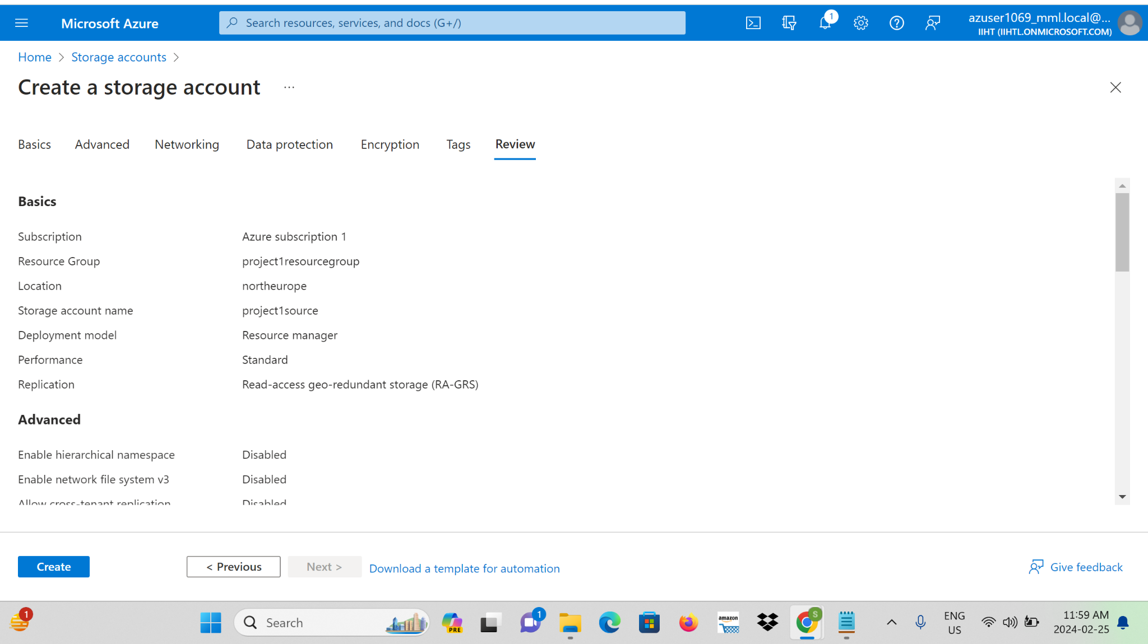

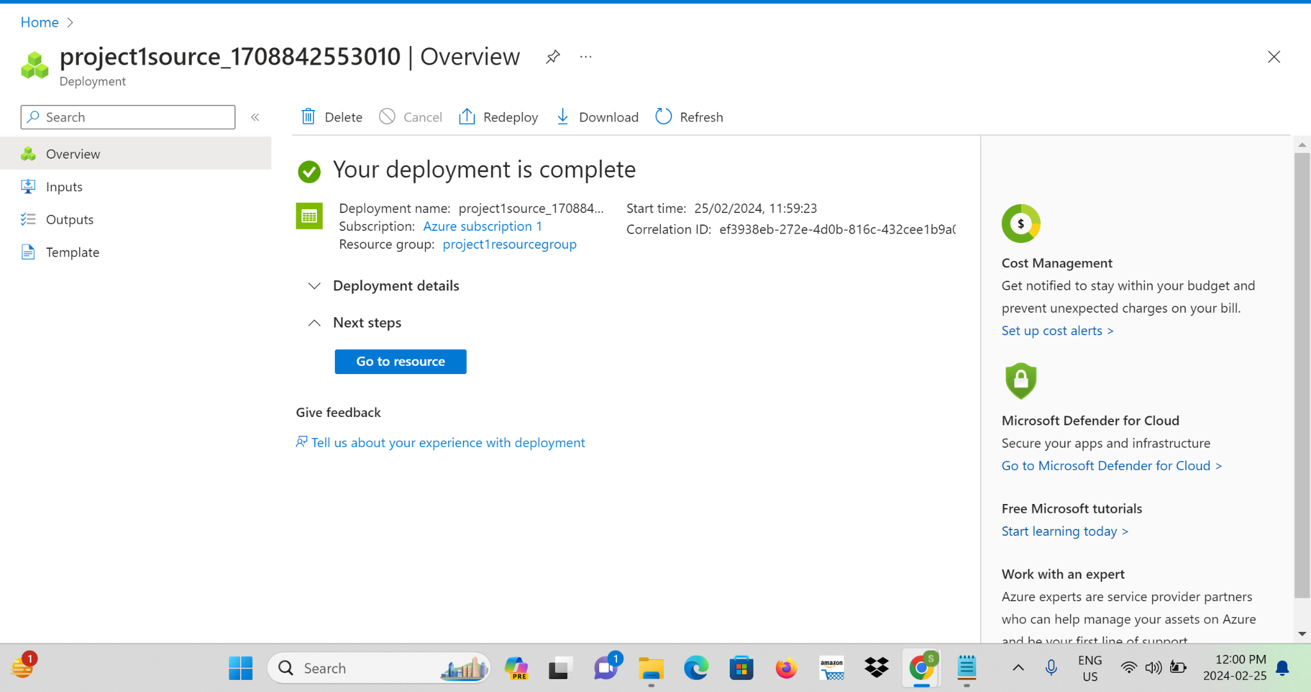

**Step 3:** After completing the storage account go to resource and search for the container.This is to upload files in the source storage account.

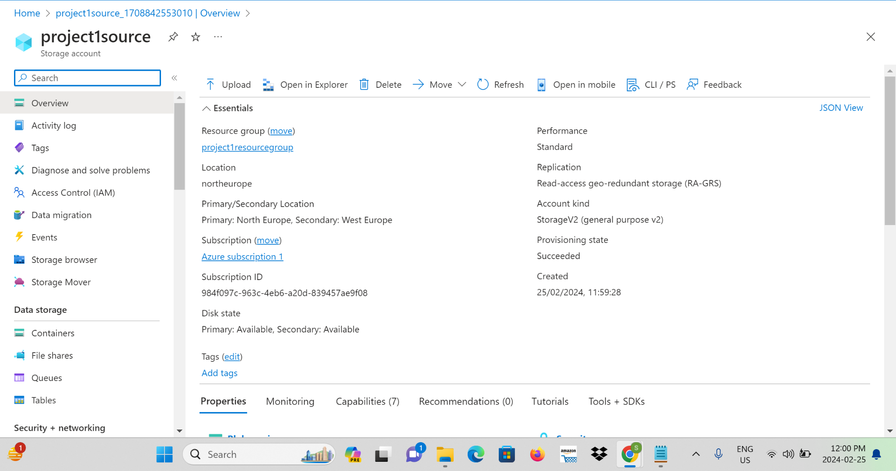

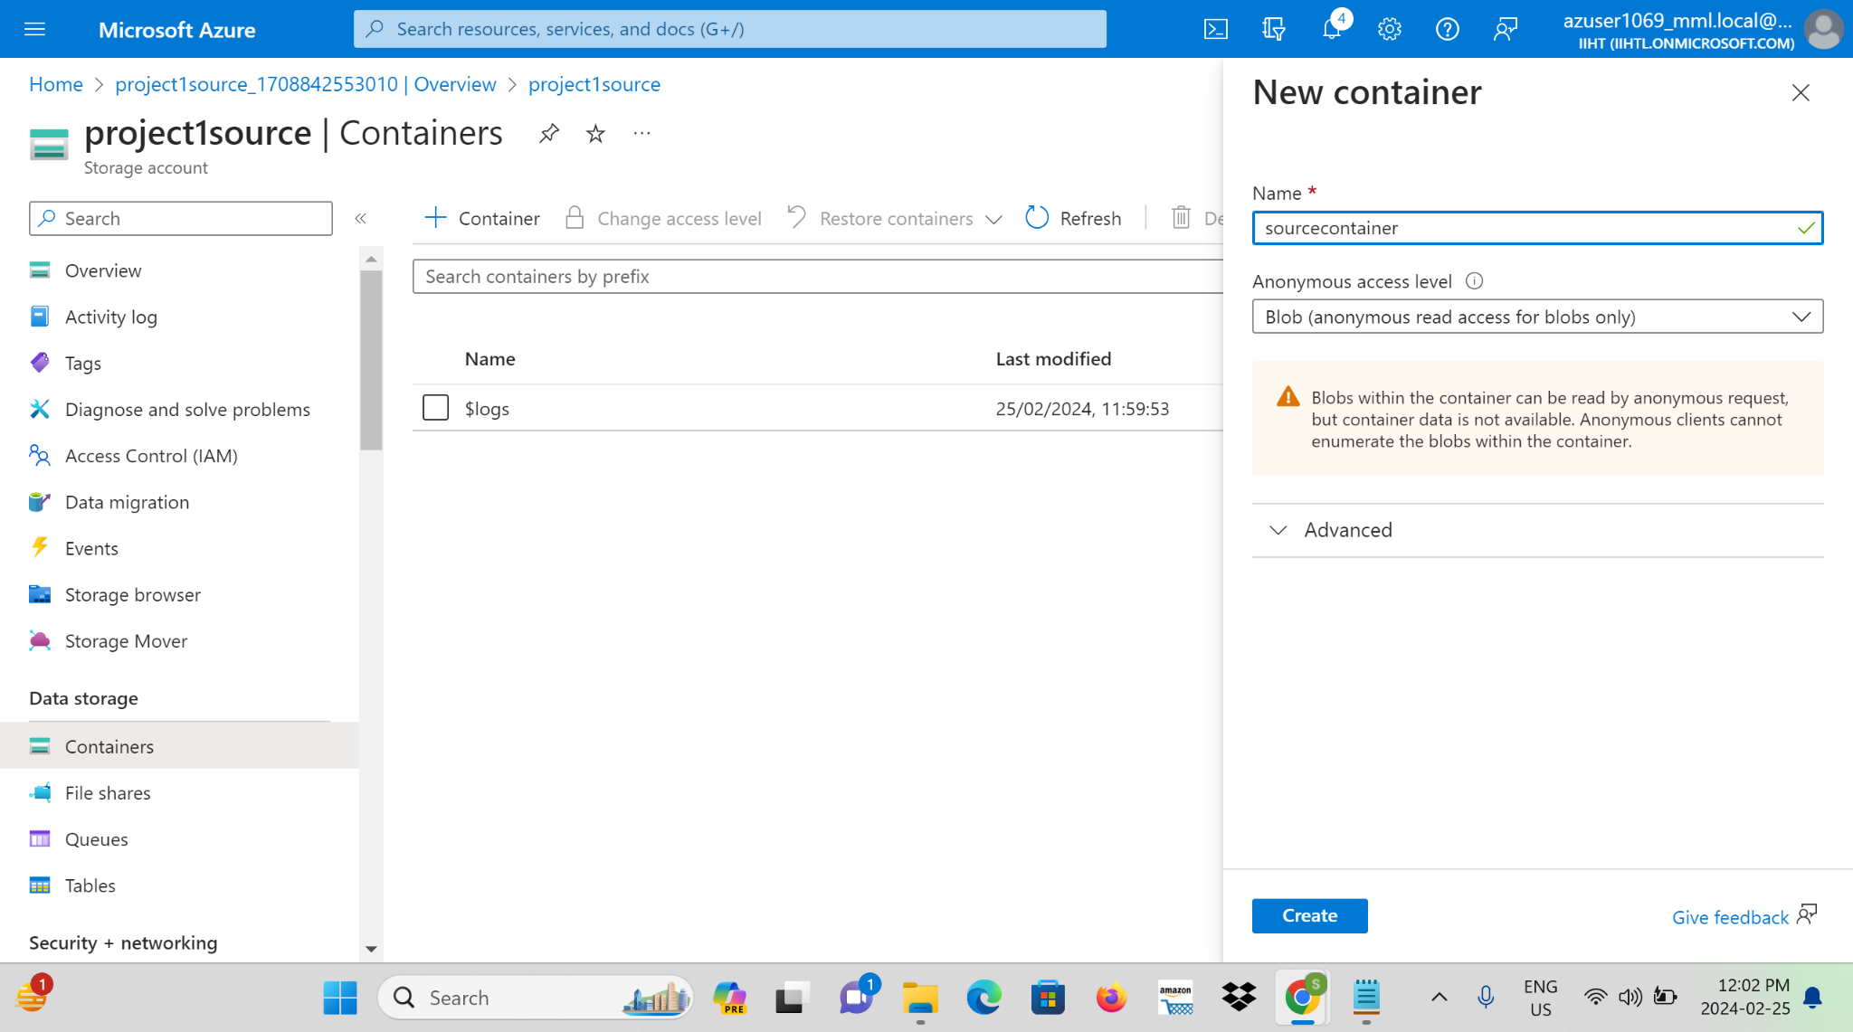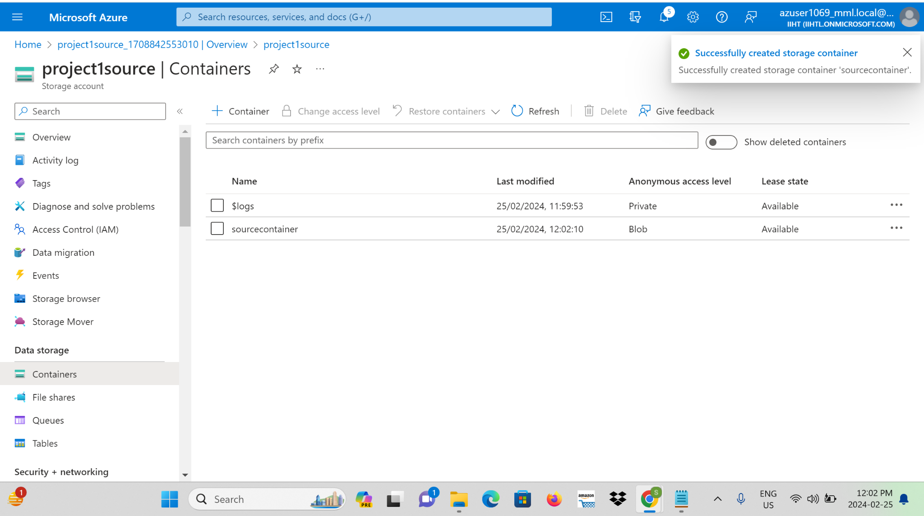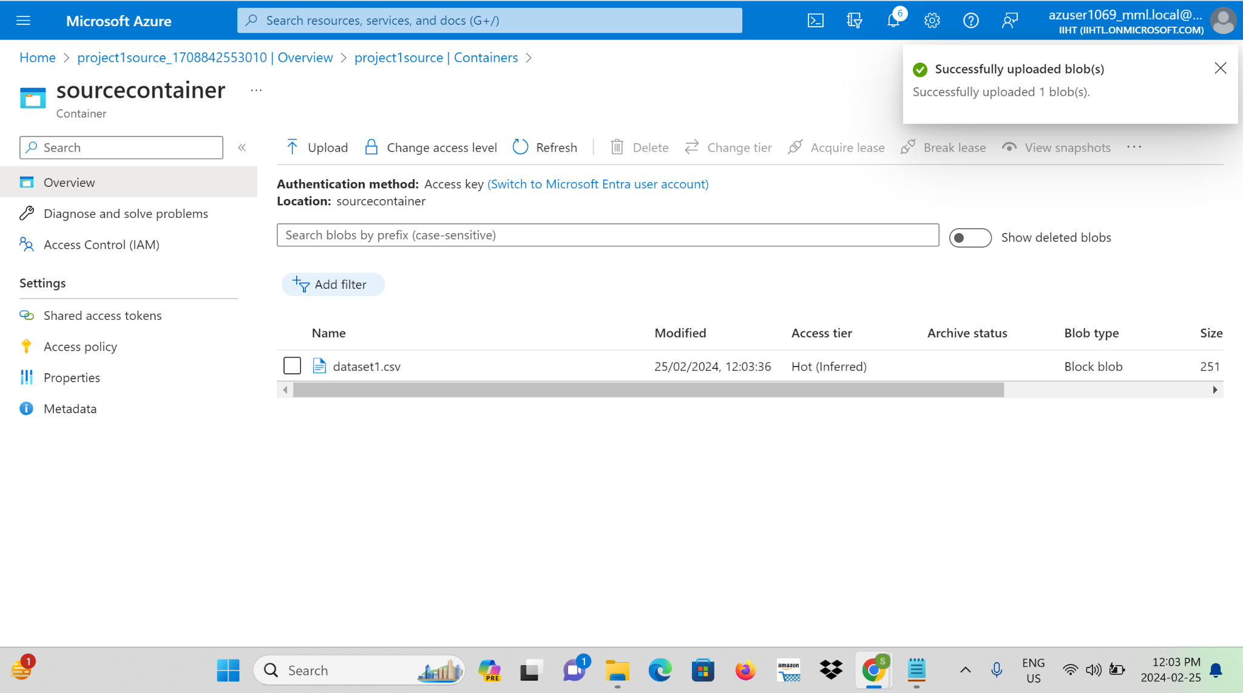

**Step 4:** Create another storage account and name it as a destination storage account and also create an empty container in it.

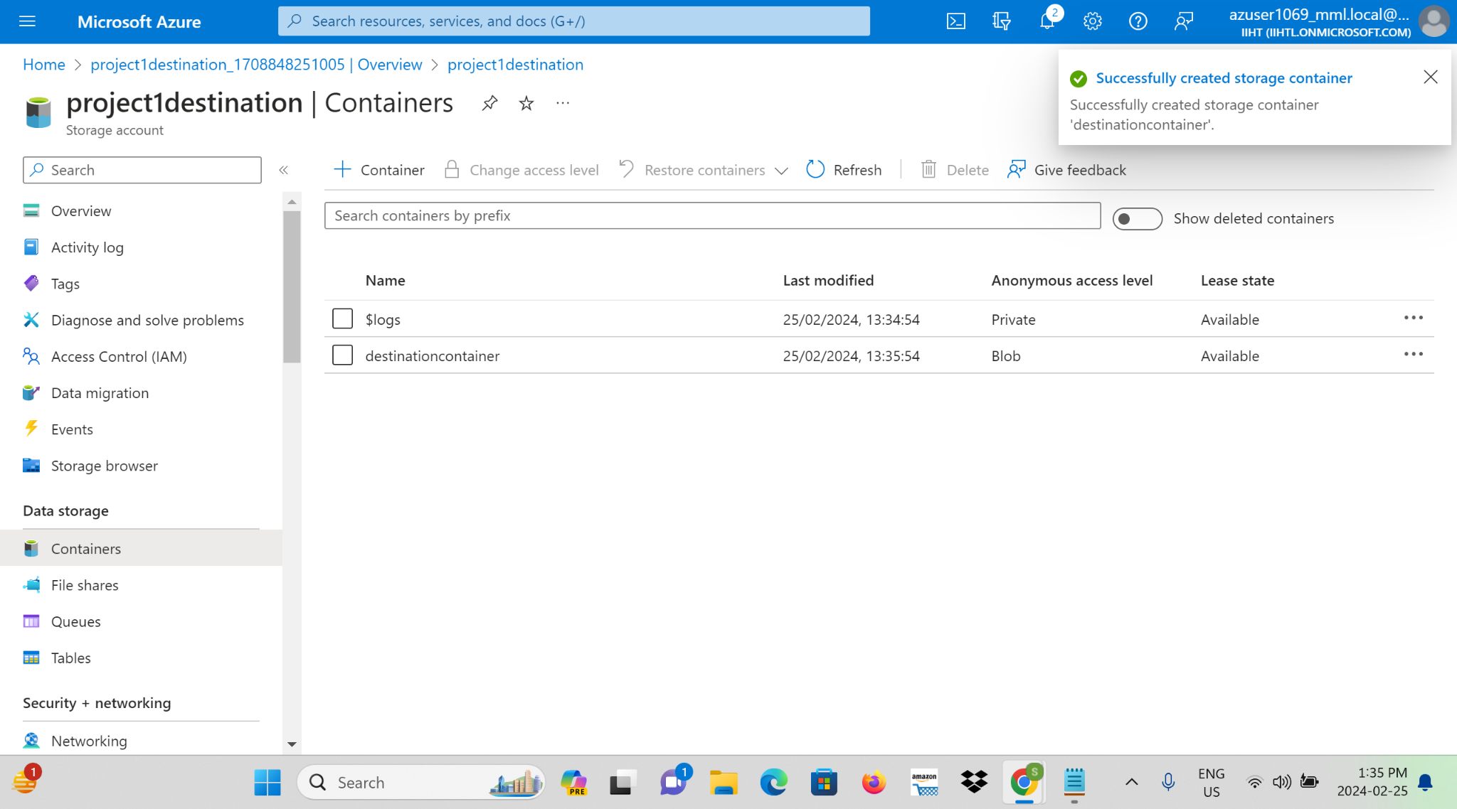

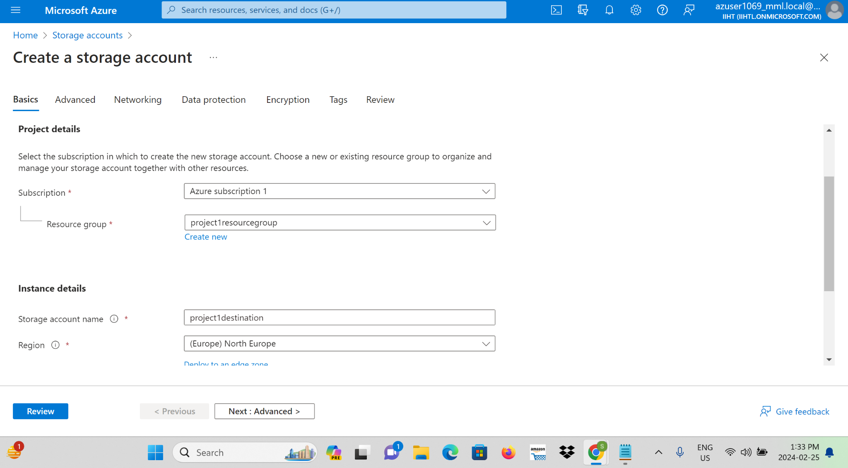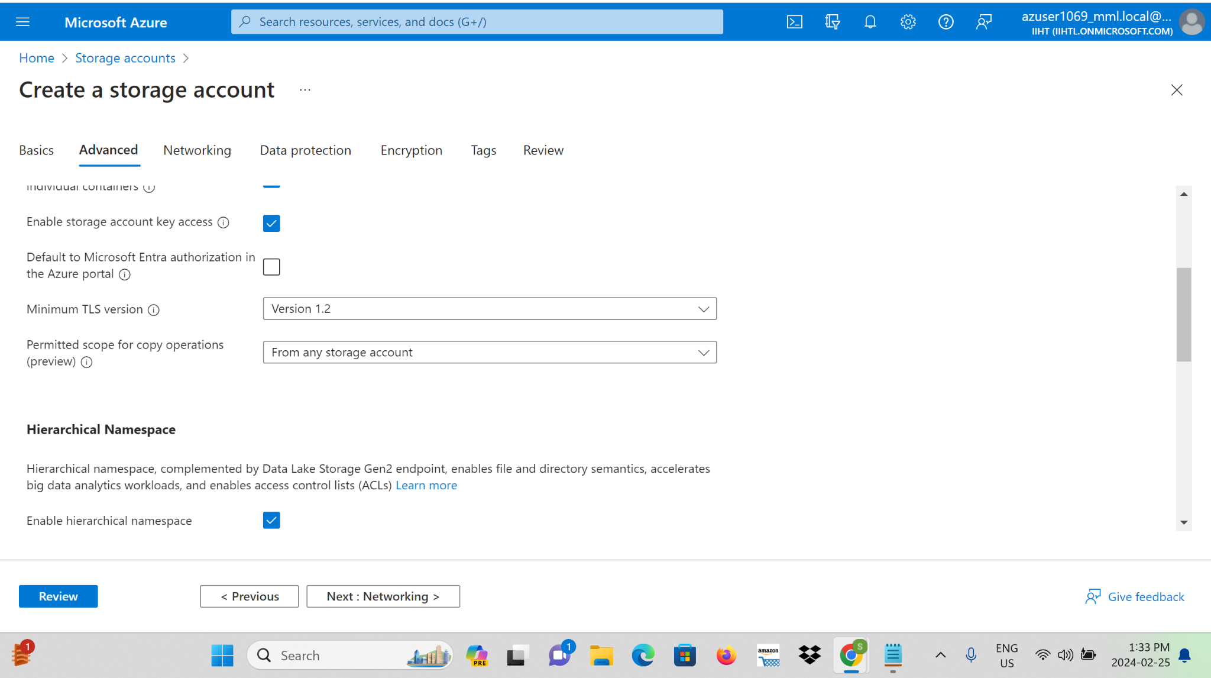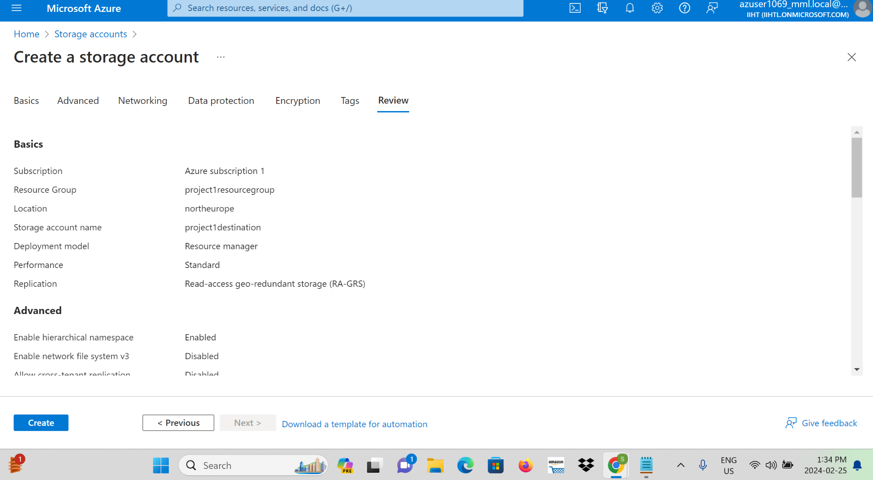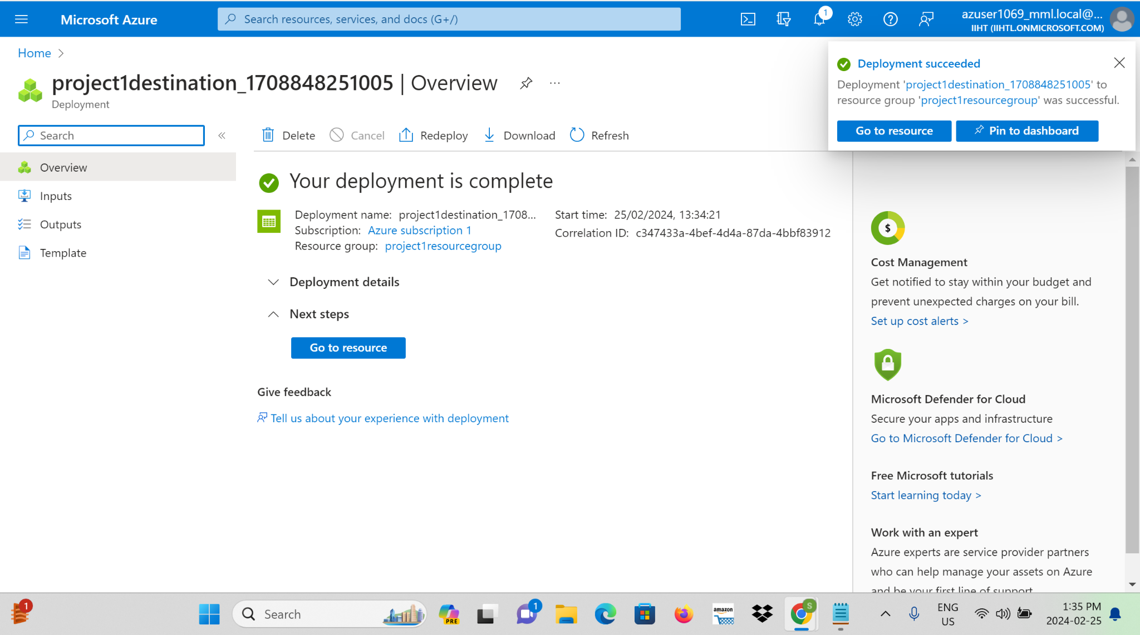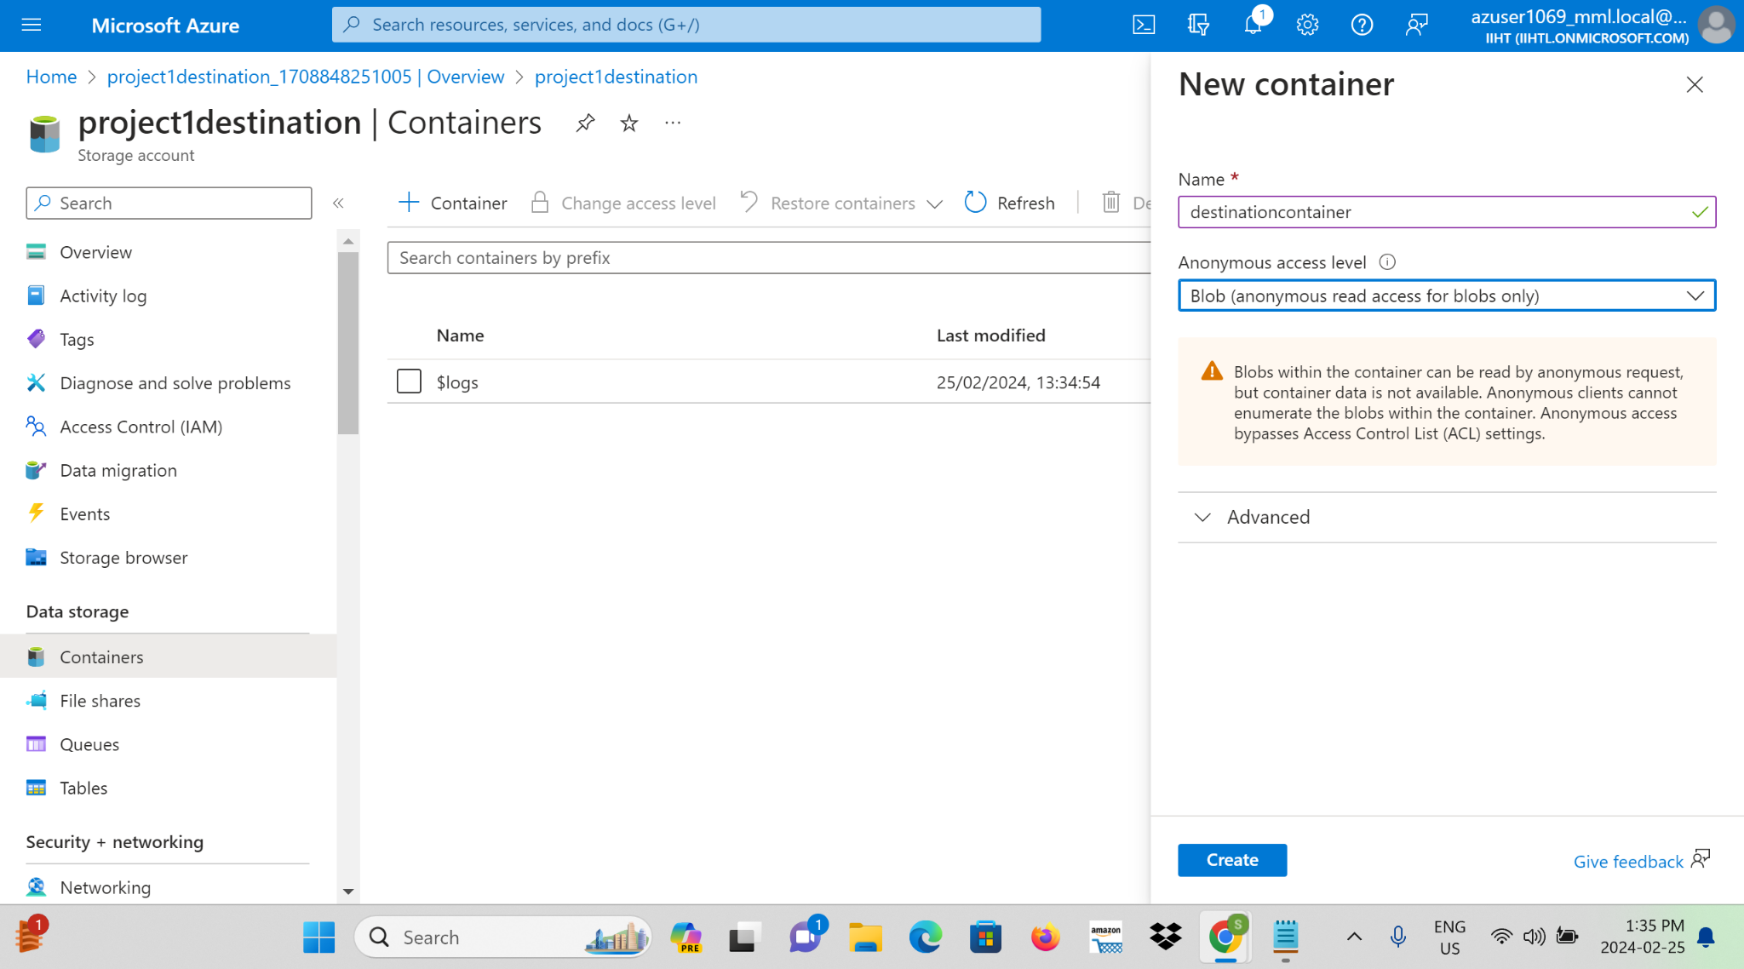

**Step 5:** Navigate to the Azure portal and search for Azure Data Factory and create a Data Factory.

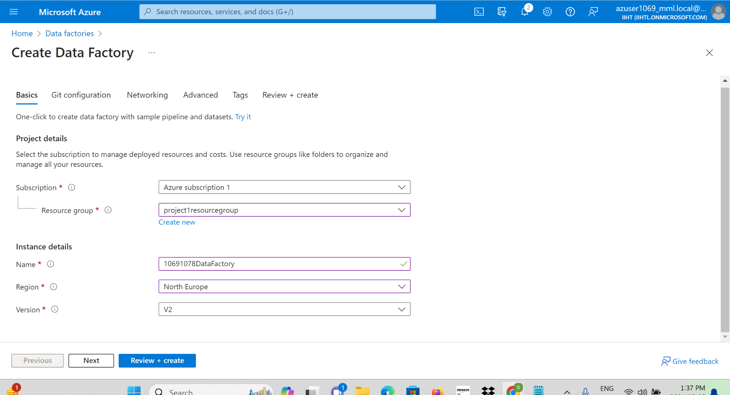

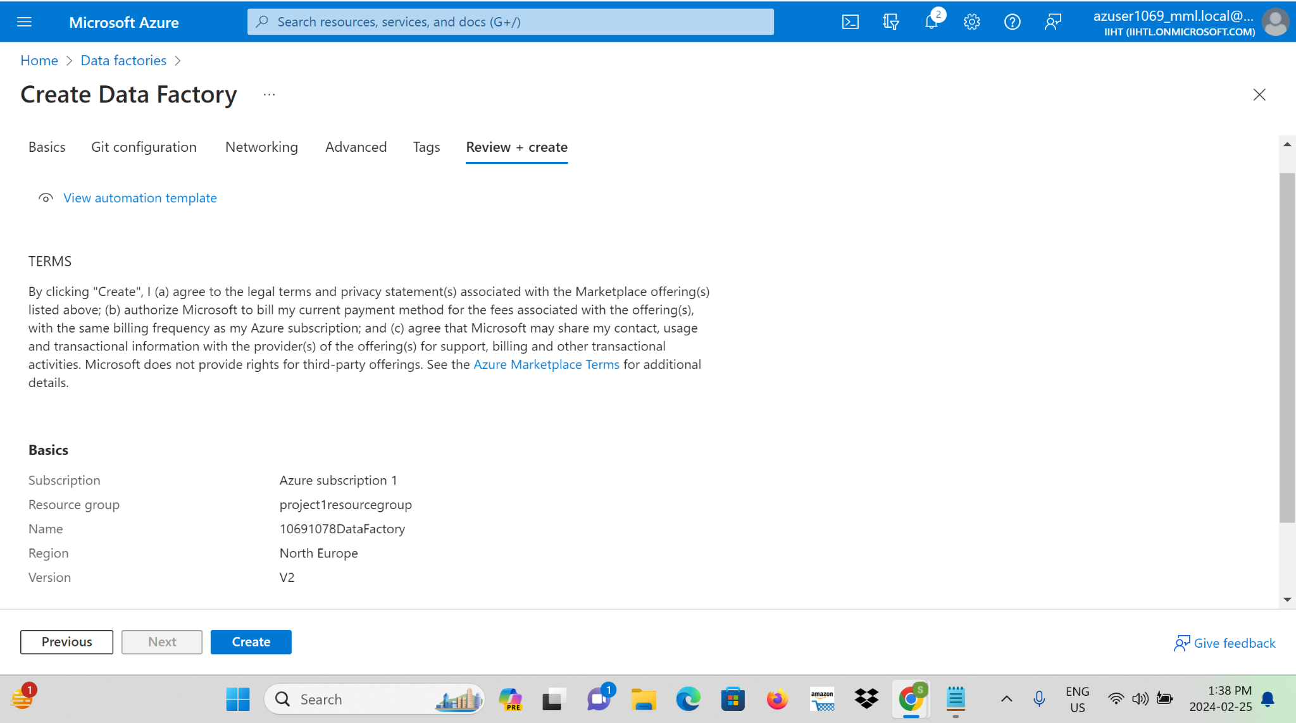

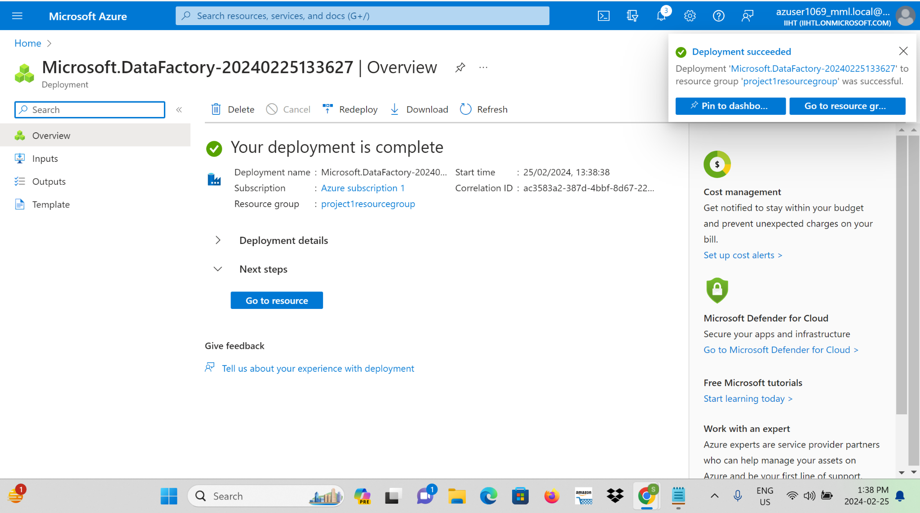

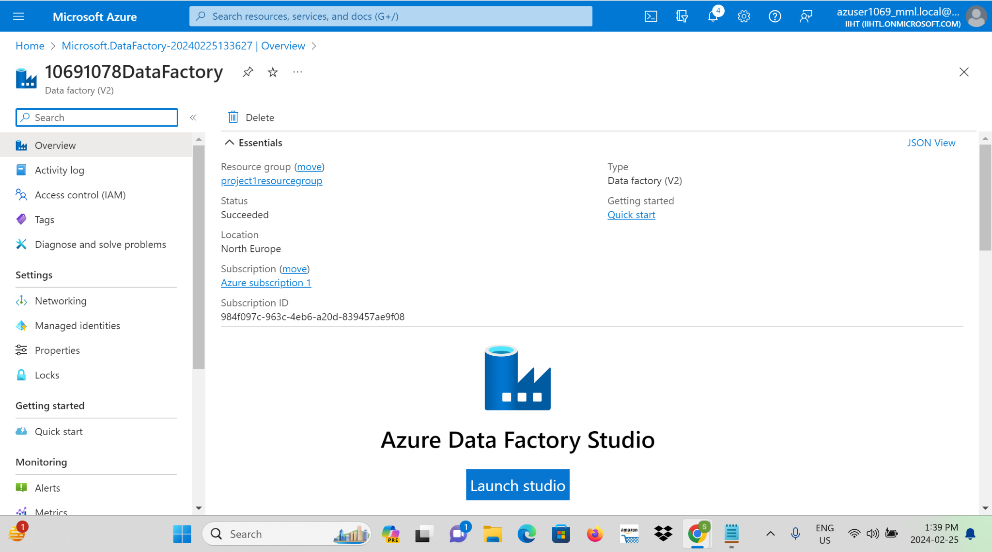

**Step 6:** Create Data Factory Pipelines utilise Azure Data Factory to design and implement data pipelines for ingesting data.

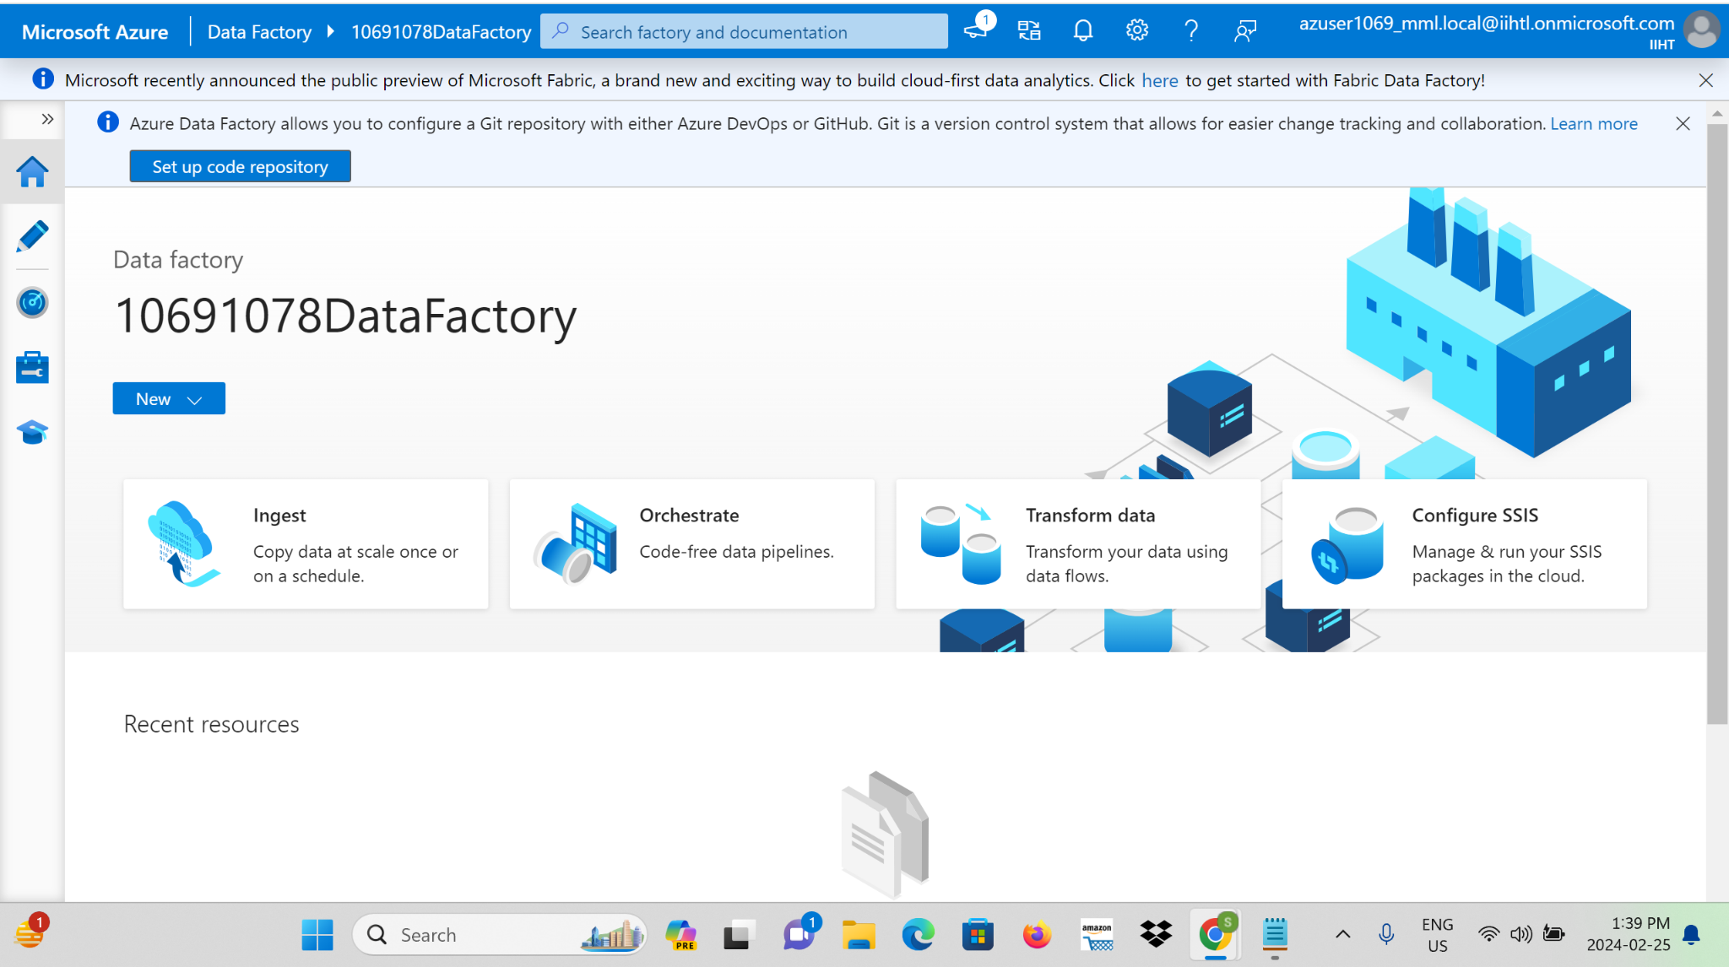

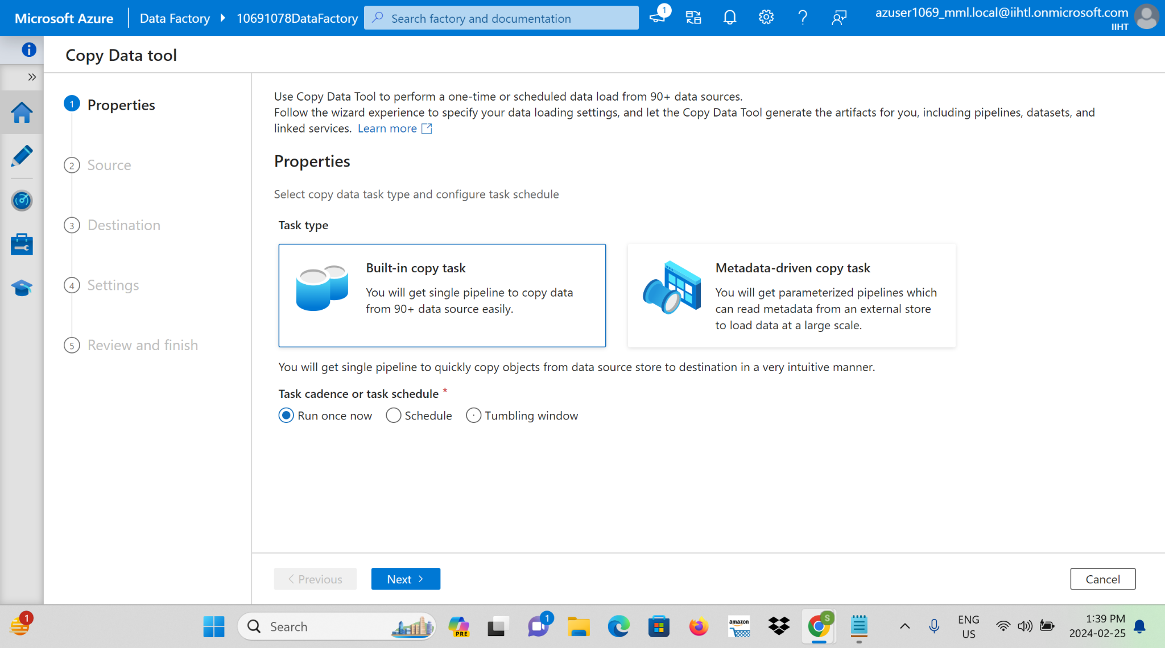

**Step 7:**Configure Blob Storage as source, specify Azure Blob Storage as the target for ingested data and give a file path to browse the file Where needed, set up real-time data ingestion to ensure timely processing.

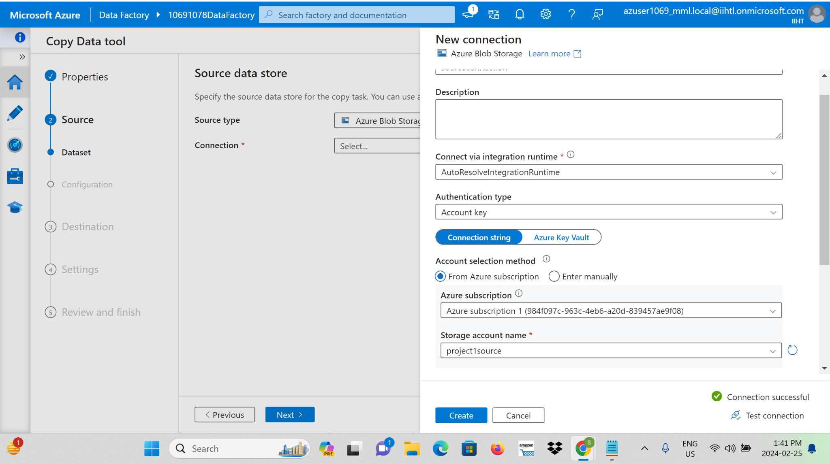

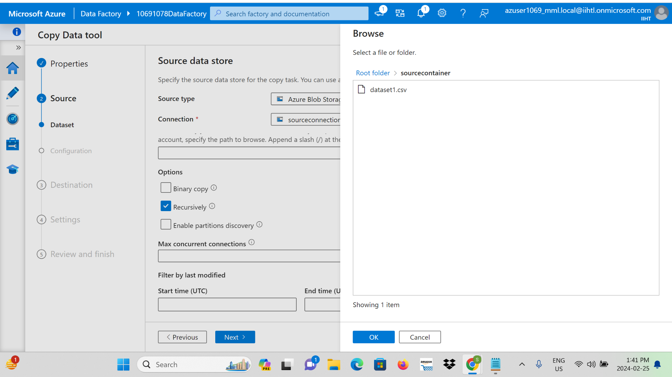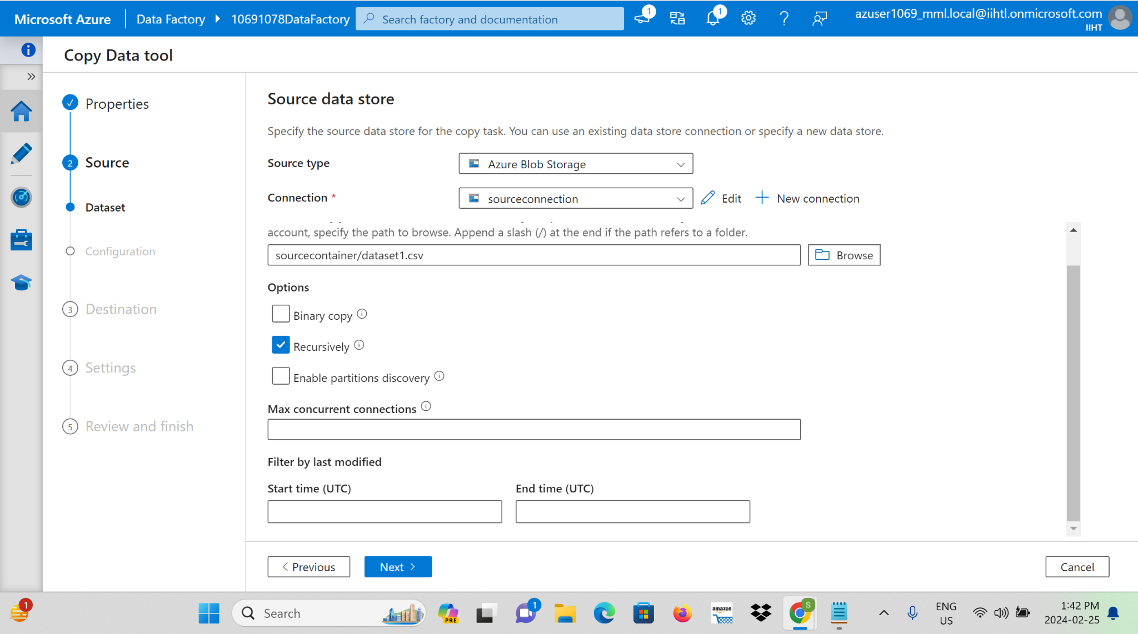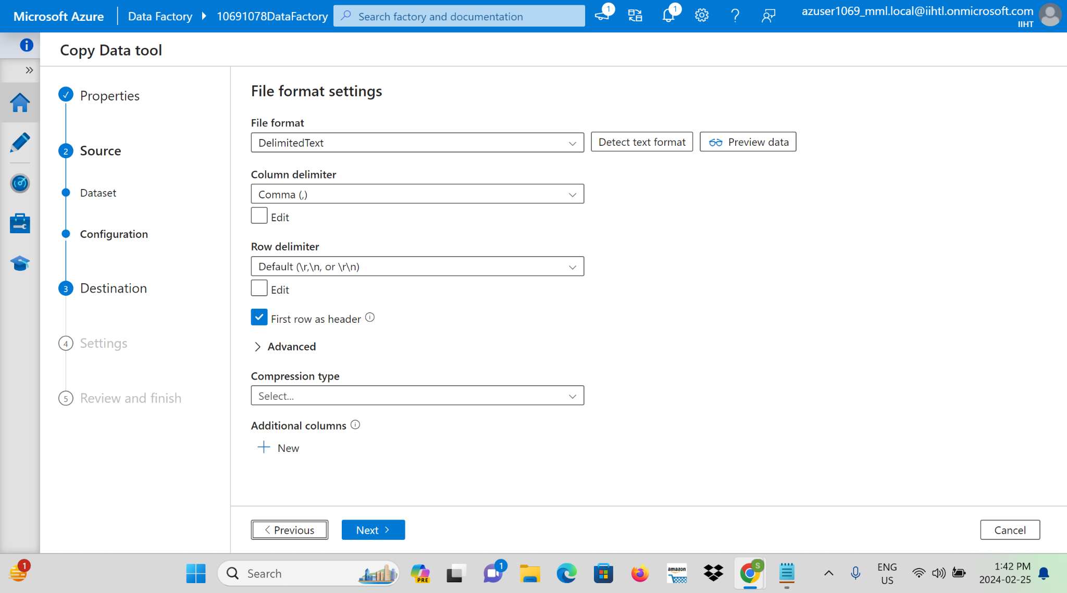

**Step 8:**Configure Blob Storage as source, specify Azure Blob Storage as the target for ingested data and give a file path to browse the file Where needed, set up real-time data ingestion to ensure timely processing.

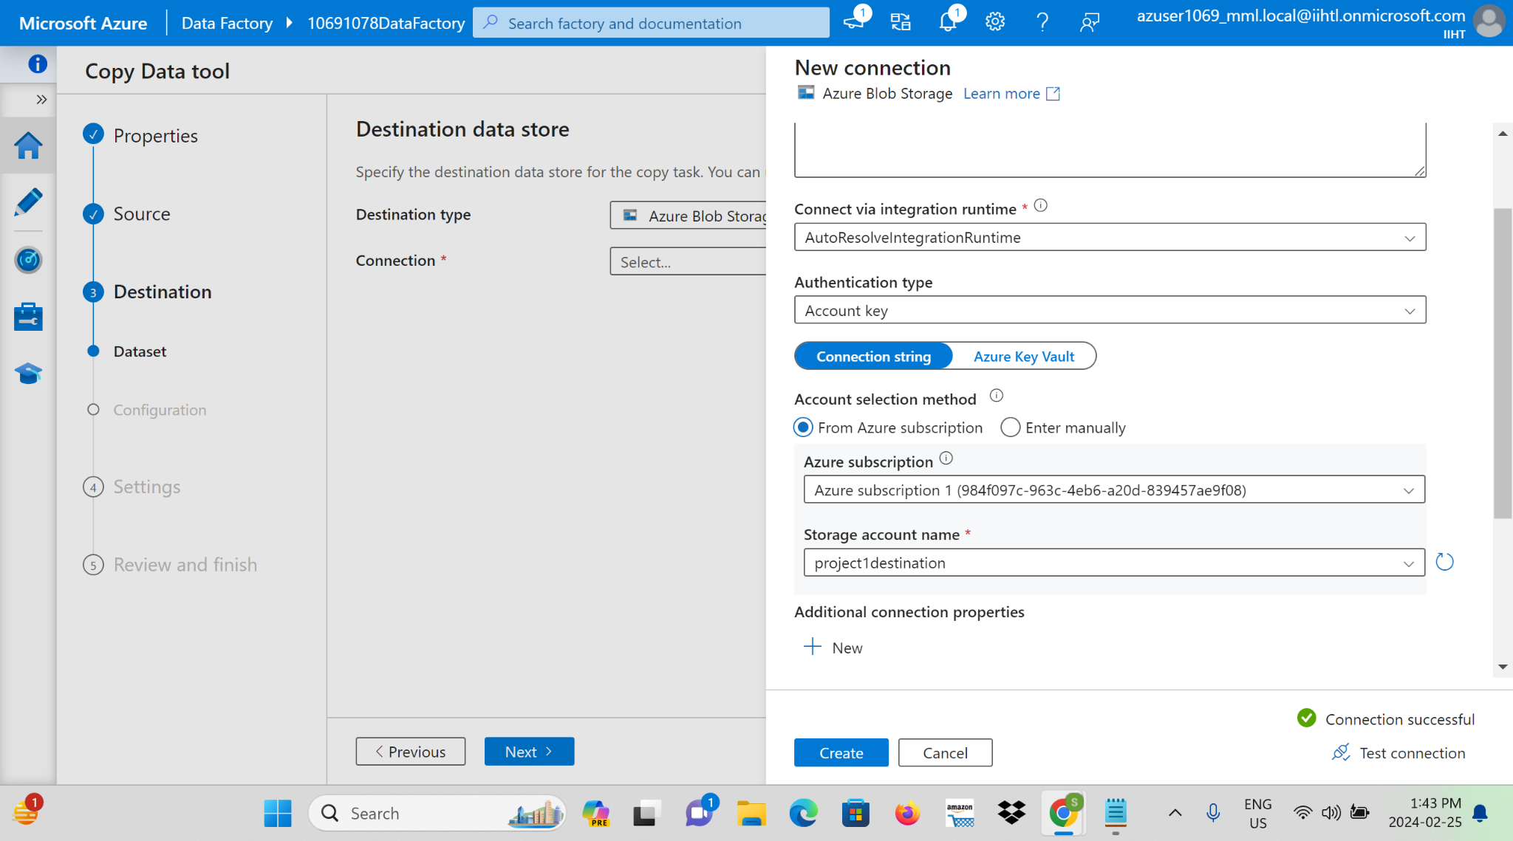

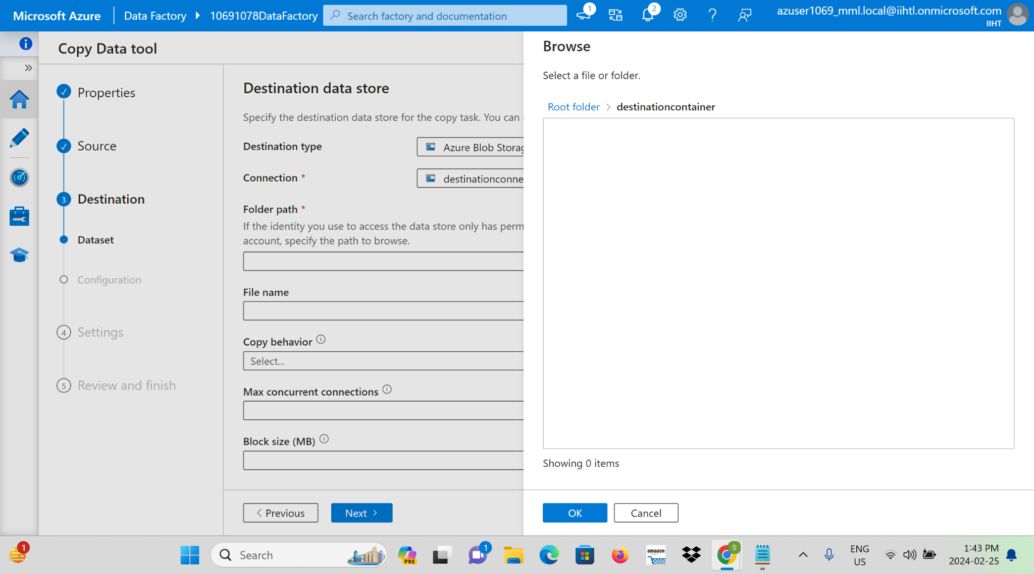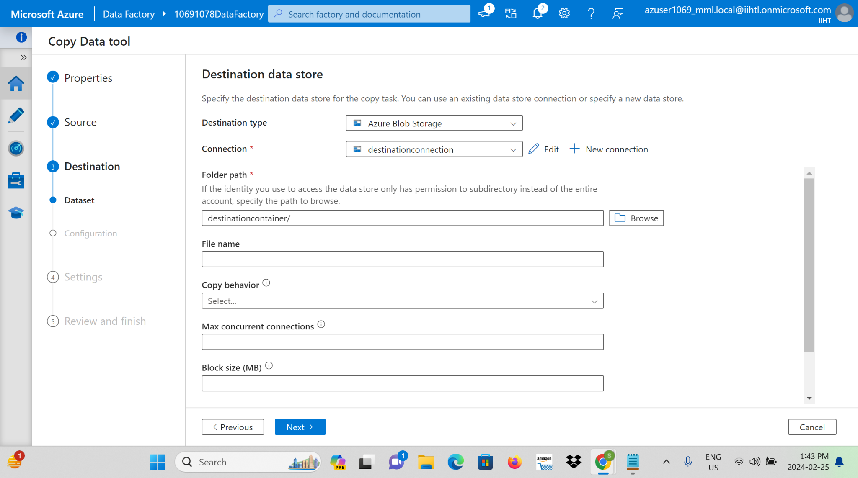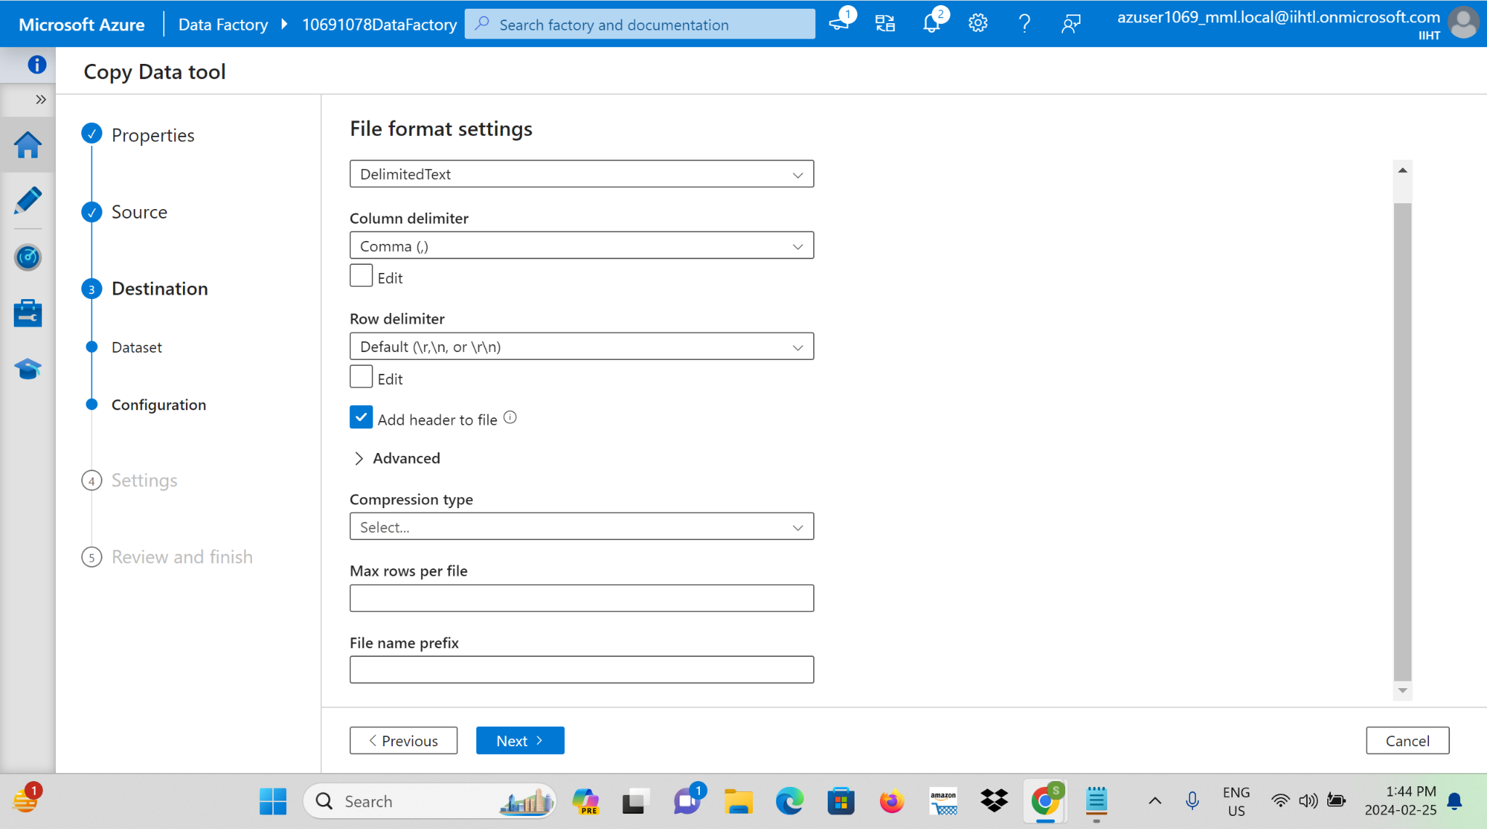

**Step 9:**We need to give the name for the copy data task .

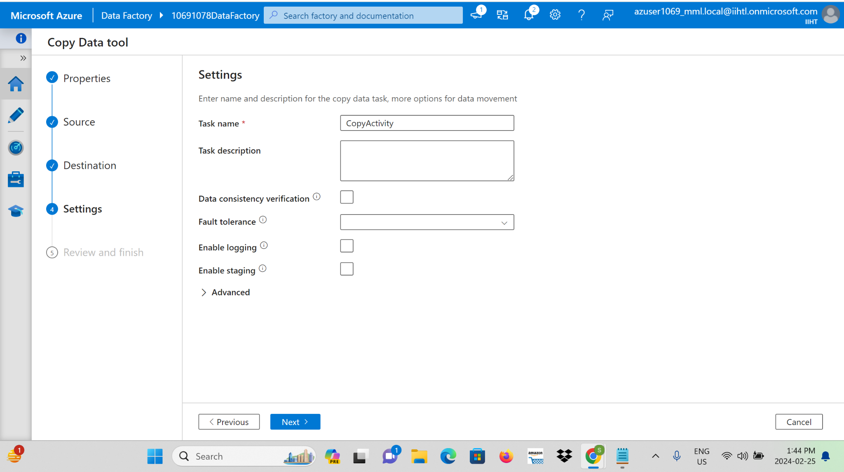

**Step 10:** Set up scheduling and orchestration within the Data Factory to ensure smooth and automated data ingestion workflows.

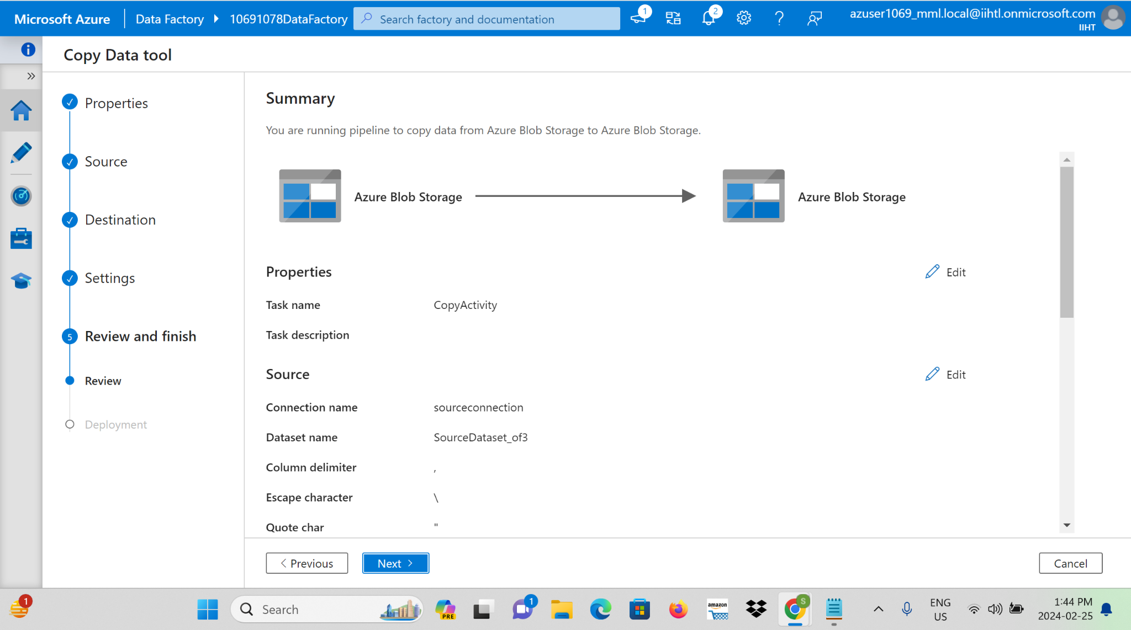

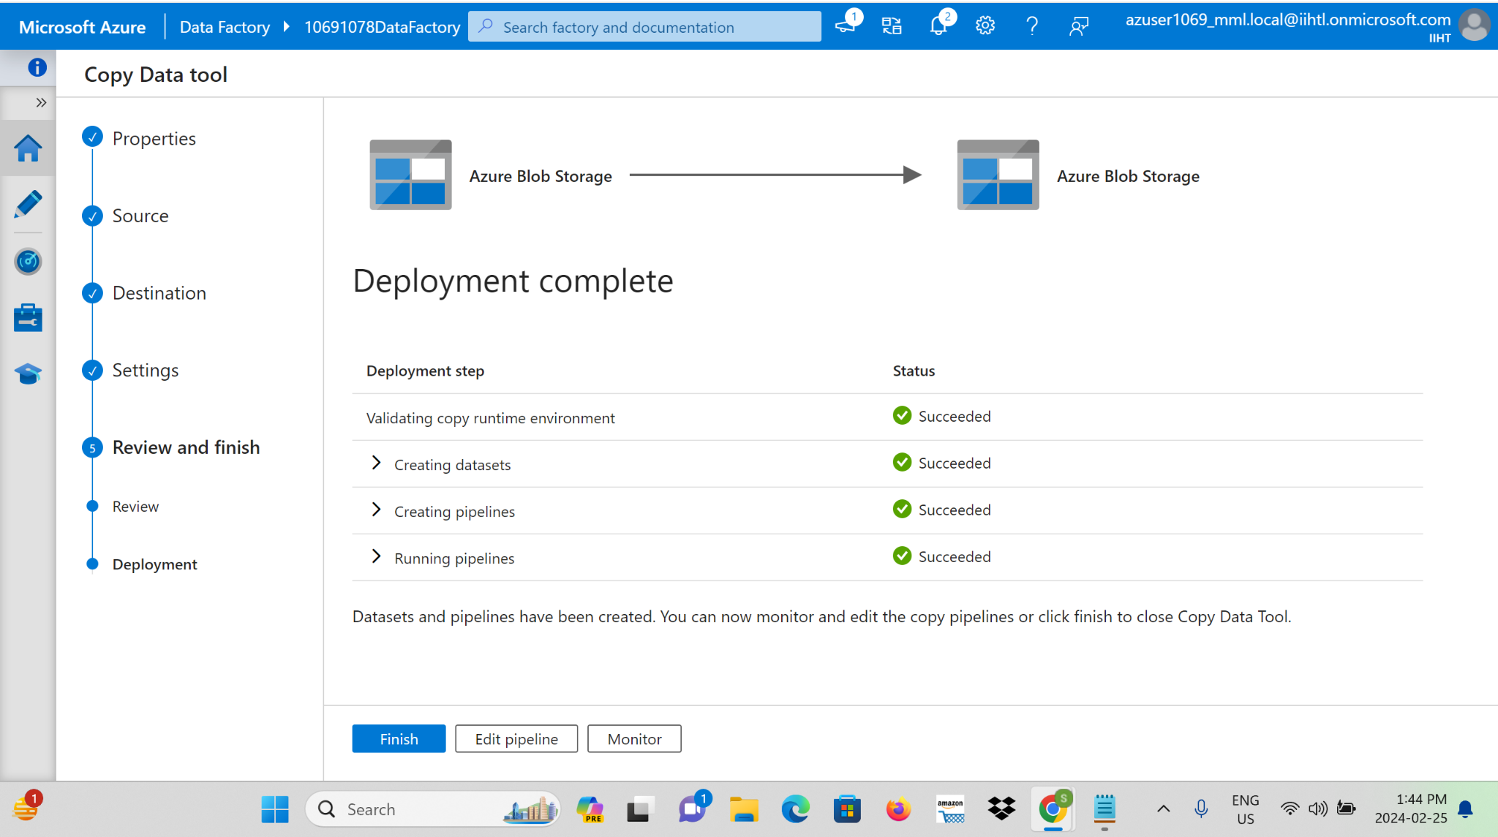

**Step 11:** Now we can see that the output for the copying activity in Azure Data Factory is the successful transfer of data from a source data store to a destination data store.

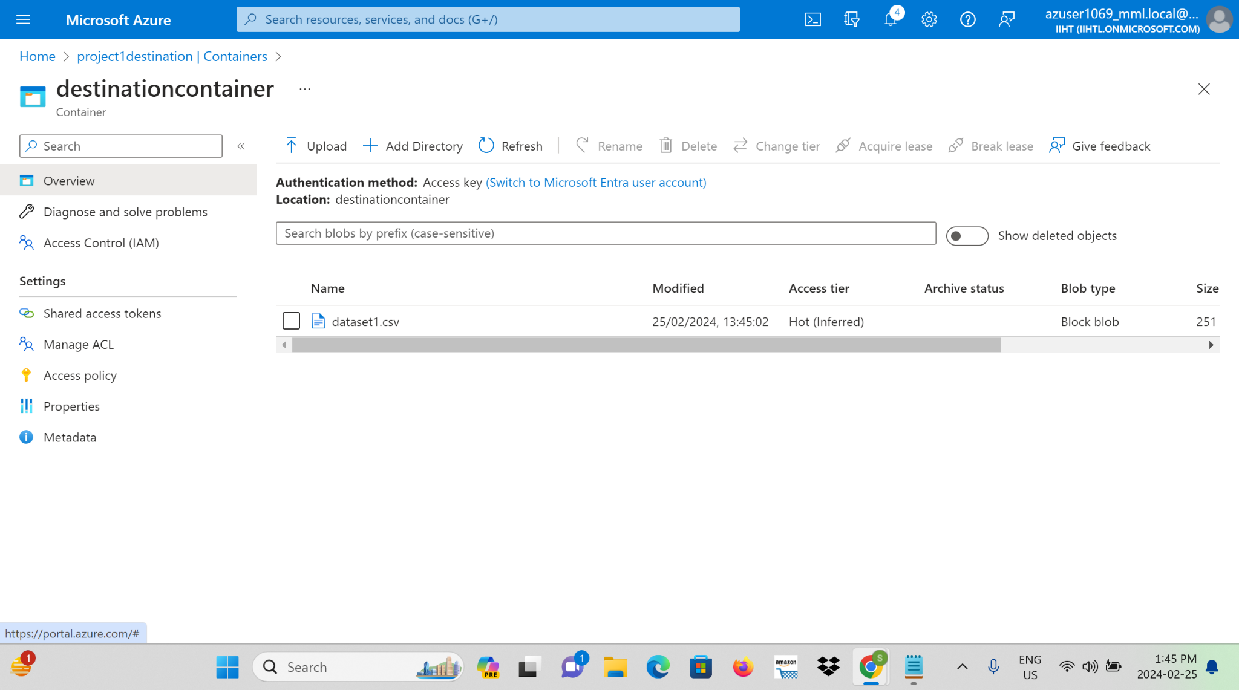

**Step 12:** validating and debugging the copy activity.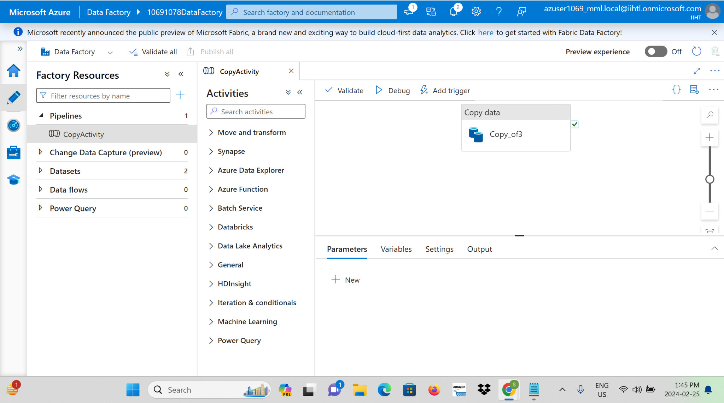

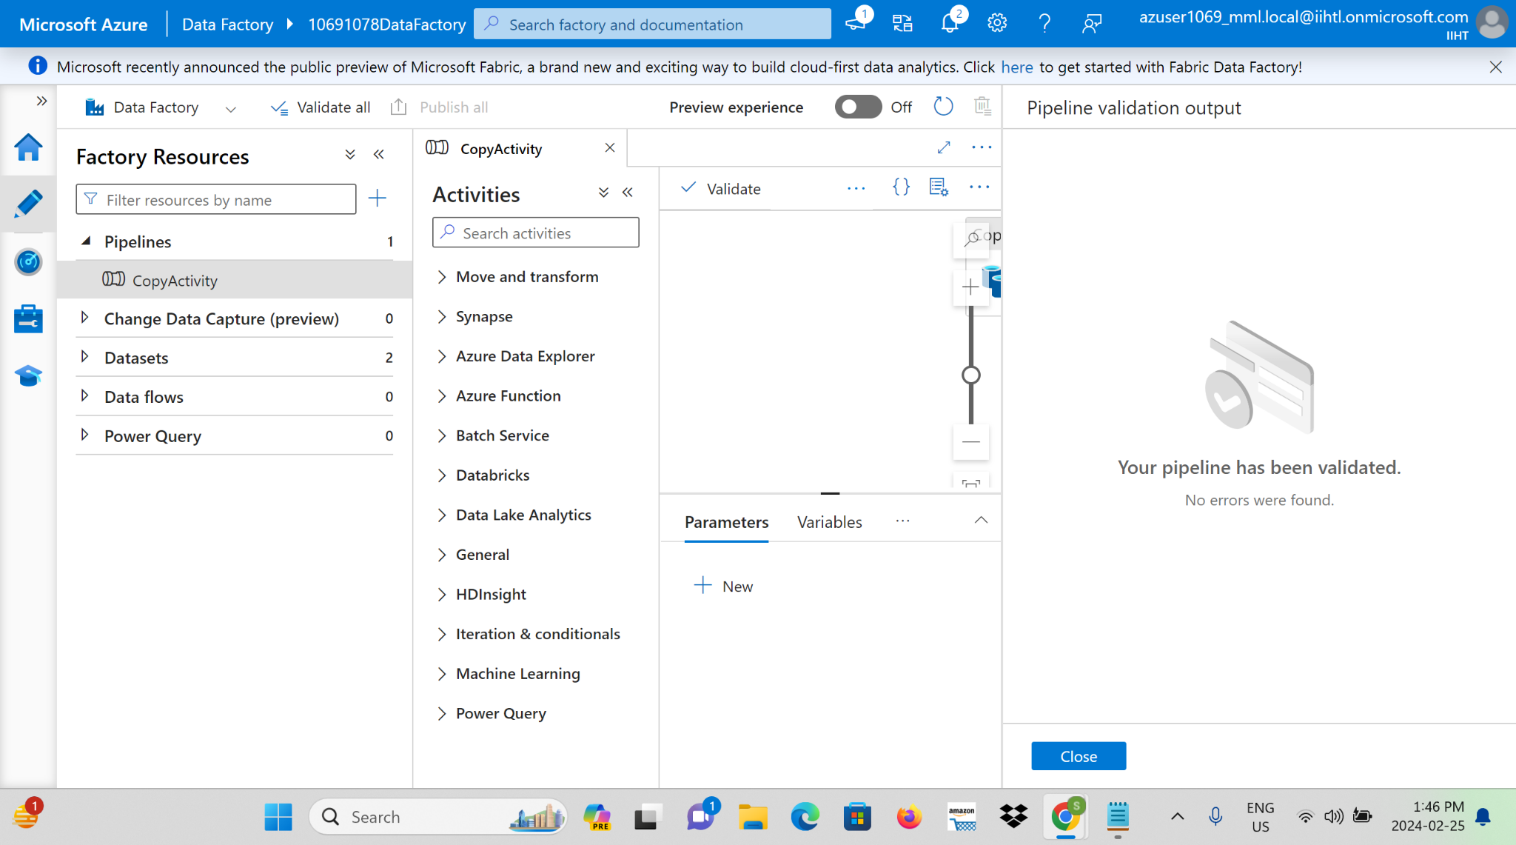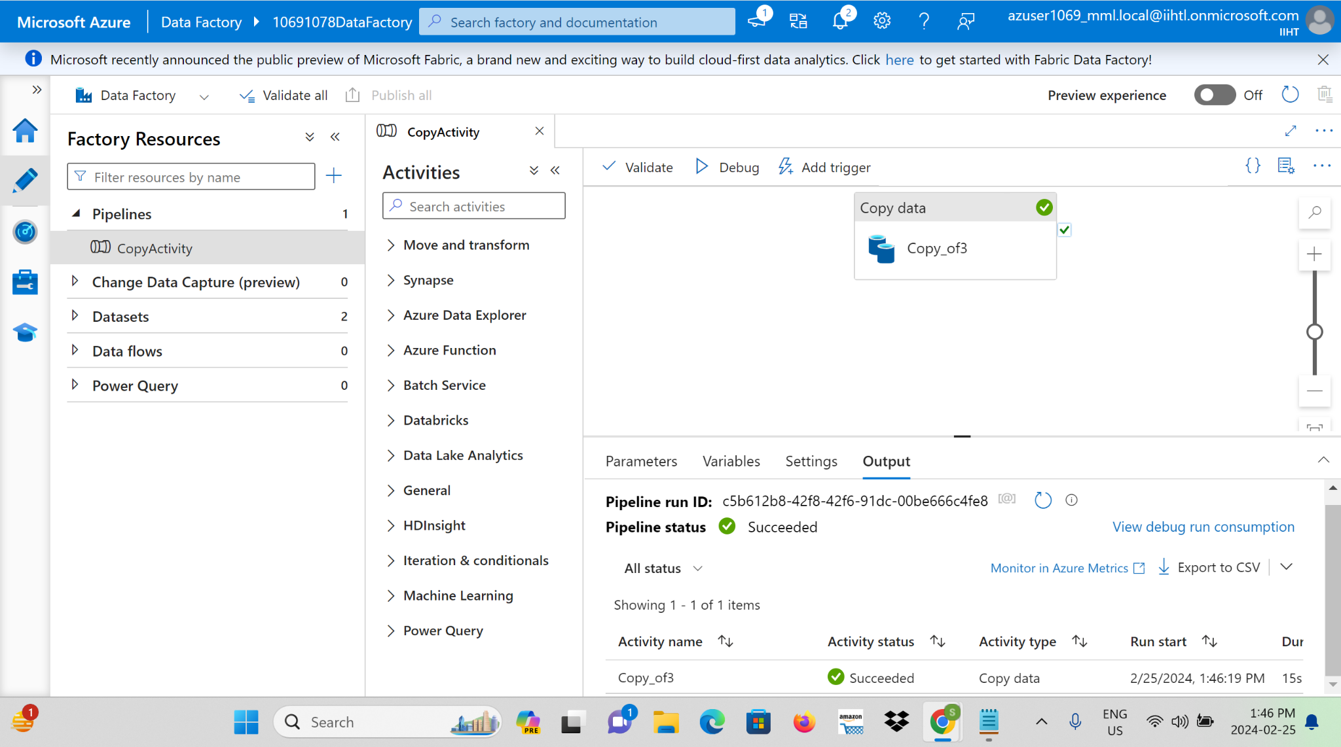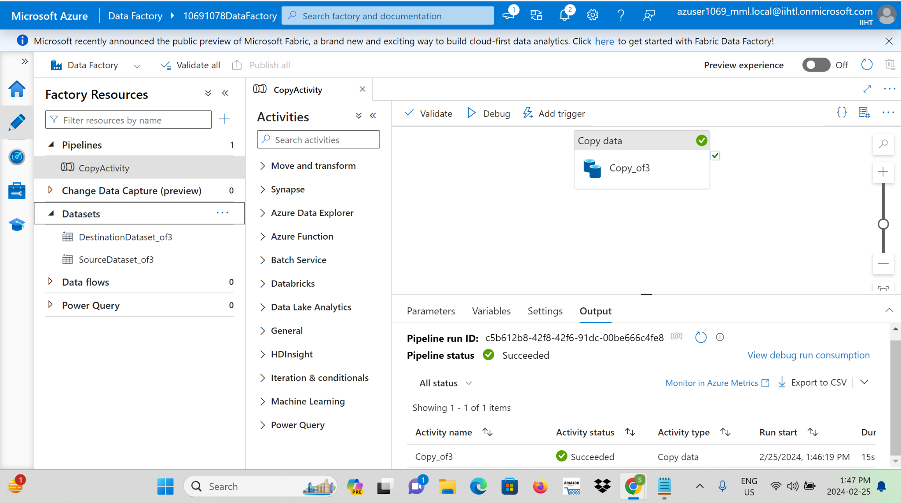

**CONCLUSION:**

This real-time data processing solution combines the strengths of Azure Data Factory and Azure Databricks, creating a dynamic and scalable architecture. It empowers organizations to derive actionable intelligence from streaming data sources in near-real-time, facilitating informed decision-making.